The parliamentary Discourse on citizenship in Germany between 1996 and 2016
A CONTEXT ANALYSIS OF THE CONCEPT OF CITIZENSHIP IN R

With friendly provision of data by:

PolMine is a project located at the University of Duisburg-Essen, The Chair of public policy and state policy, and is a member of CLARIN-D.

The parliamentary discourse on citizenship in Germany between 1996 and 2016.
A context analysis of the concept of citizenship in R.
Submitted as
Bachelor’s thesis
for attainment of the academic degree of
Bachelor of Arts
– B.A. –
presented by
Kevin Glock
born in Hamm (Westphalia)
Faculty of Social Studies,
Institute for Political Science
of
University of Duisburg-Essen.

First supervisor: Professor Andreas Blätte
Professorship of Public Policy and State Policy
Faculty of Social Sciences
Institute of Political Science
Second supervisor: Merve Schmitz-Vardar, M.A.
Research assistant at the Professorship of Public Policy and State Policy

6th semester,
kevin.glock.1@stud.uni-due.de
Submitted on Monday, October 14th, 2019

Symbols (without spaces) 101.986
Symbols (with spaces) 119.865

Table of Contents
Table of Contents II
List of Tables III
List of Figures III
Glossary of Terms IV
Glossary of Abbreviations IV
Notes on quotes and terms V
1 Introduction 1
2 Theoretical Approach 3
2.1 The concept of citizenship 4
2.2 Citizenship Act in and immigration to Germany 7
2.3 Applied framework 10
2.3.1 Definition of discourse 11
2.4 Salience on immigration 13
2.4.1 Hypothesis 1 14
2.5 Parties’ ideological difference 14
2.5.1 Hypothesis 2 16
2.6 Explanandum 16
2.7 Parties´ ideological convergence and divergence in linguistic contextualisation 17
3 Methodology and Data 19
3.1 Computer-assisted content analysis 19
3.2 Corpus linguistical approach 20
3.2.1 Corpus linguistical methods 20
3.2.2 Dictionary 21
3.2.3 Classification scheme 22
3.2.4 polmineR 22
4 Results 25
4.1 Changes of salience of immigration over time 25
4.2 Party actors´ salience on citizenship 27
4.3 Parties’ linguistic context convergence 32
4.4 Parties´ linguistic context divergence 35
5 Implications 39
6 Conclusion and Limitations 43
7 References 44
8 Appendix A
8.1 Statutory declaration A

List of Tables
Table 1 Sorted and validated dictionary of the citizenship policy field in Germany formulated from theoretical model and adapted from Green (2004: 2) 22
Table 2 classification scheme, adapted from Helbling (2012), own illustration 22
Table 3 Collocations of '".*[Ss]taatsbürger.*"' between 1996 and 2000 by party (only similar ones) 33
Table 4 Collocations of '"[Mm]ehrstaat.*"' for 1996 to 2016 by party (partial low counts for LINKE and Greens; without duplicates) 35
Table 5 classification scheme, adapted from Helbling (2012), own illustration 36

List of Figures
Figure 1 Structural and positional attributes of GermaParl 23
Figure 2 Size of GermaParl corpus & Time span in years/ legislative periods encompassed by GermaParl 23
Figure 3 Immigration rate, relative frequencies of Foreigners´ Policy, citizenship, and dual citizenship between 1996 and 2016 (form top left to bottom right) 26
Figure 4 Relative frequencies of citizenship related words from dictionary between 1996 and 2016 28
Figure 5 Relative speech frequencies of dual citizenship related words from dictionary between 1996 and 2016 28
Figure 6 Relative speech frequencies of Foreigners´ Policy related words from dictionary between 1996 and 2016 29
Figure 7 Smoothed average functions of total immigration rate, total Foreigners´ Policy field, citizenship, and dual citizenship (from top left to bottom right) 32

Glossary of Terms
Basic Law | Grundgesetz
Citizenship Act | Staatsangehörigkeitsgesetz
Committees | Ausschüsse
Ethnic German (resettlers) | (Spät)Aussiedler
Foreigners´ Law | Ausländergesetz
Foreigners’ Policy | Ausländerpolitik
Foreigners´ Politics | Ausländerpolitiken
German civil servants responsible for integration of foreigners | Ausländerbeauftragte
German Imperial and Nationality Act | Deutsches Reichs- und Staatsangehörigkeitsgesetz
Immigration Act | Einwanderungsgesetz
Nationality Act | Staatsangehörigkeitsgesetz
Parliamentary group / party | Fraktion
Political persecutees | politisch Verfolgte
Suspension of deportation | Duldung (Aussetzung der Abschiebung)
Tolerance permit | Duldung (genehmigter Statusaufenthalt)
Volga German(s) | Russlanddeutsch(e)

Glossary of Abbreviations
Cqp | Corpus query processor
CWB | Corpus workbench
Html | Hypertext markup language
rcqpCWB | r package combining the rcqp package and the CWB for text processing
XML | Extended markup language

Notes on quotes and terms
All quotes within the text were translated into English to support the reading fluency. The analysis is based on German text resources, therefore all terms and sentences included in the analysis are also stated in German within the text of this paper. To mark terms from the analysis they are written with [squared brackets]. Methods (functions) are written like in the command line within the programming language R (i.e. “count()”). Accentuations, reprimands, and brands are written in cursive. German proper names of institutions or related are written in German and in cursive. The reader may be directed to the Glossary of terms for related terms in English.

Abstract:
The aim of the paper is to analyse the contextualisation of the parliamentary citizenship discourse by using descriptive time-series analysis and linguistic context analysis to detect salience effects of immigration on individual actors’ speech and parties’ linguistic and ideological contextualisation on Bundesebene. Following the research questions regarding (dual) citizenship, the paper at hand examines parliamentary debates between 1996 and 2016 in Germany. Protocols from the German Bundestag are examined. The database and software infrastructure are taken from PolMineR and the offered corpus GermaParl. The results suggest that the total Immigration rate is highly correlated with the speech frequencies of used terms referring to Foreigners´ Policy and to a lesser degree with citizenship aspects as well. In addition, they imply a high salience effect on parliamentary discourse through the total immigration rate. Single aspects of naturalisation and asylum application have to be considered. Between parliamentary parties, there are significant convergences in linguistic contextualisation of citizenship issues. However, divergent viewpoints exist regarding dual citizenship and the compulsory option model, as well as its ideologic framings.

Introduction
Citizenship issues have become increasingly relevant in the Western hemisphere, especially in the case of Germany, since increasing migration rates in 2015/16 known as the ‘refugee and migrant crisis’ (Berry et al. 2016). Regarding recent migration dynamics in the ‘age of migration’ as Castles et al. (2014) call it and the following debates about dynamics of integration in European countries (Rauer and Schmidtke 2001, Niessen et al. 2007, Öztürk 2007, Riegel 2009, Langthaler 2010, Algan et al. 2012, Hunger 2014, Schmitz-Vardar 2018), the relevance of migration and integration research increased (Koschyk and Stolz 2001, Jacobs and Rea 2007, Worbs 2008, Extra and Spotti 2009, Helbling 2013). Albeit research relevance in Europe raises, most published articles between 1994 and 2018 originate from the USA and Britain. A huge bias exists between research in anglophone countries and research in other European countries. Although there are some 200 published articles in Germany, they refer to the last 29 years of research, which implies that further research is necessary regarding dynamics of migration and integration, as well the prevailing absence of evidence in citizenship research in Germany. The paper at hand will help reduce this bias of research and brings new evidence on citizenship-related issues in the case of Germany from a political science perspective applying a corpus linguistical approach.
In general, it is a politically often-discussed topic whether citizenship brings benefits vis-à-vis integration of migrants through constructing identity, and whether dual citizenship is counterintuitive for an integration process because of a conflict of loyalty to two nations. Thereby arguments for and against concepts of transnationalism and nationalism were often brought into public debate whilst there are neither sufficient and comparable statistics about people with dual citizenship, nor does valid evidence exist for a positive or negative effect on integration processes in general (Ersanilli and Koopmans 2010, pp. 773–774, Helbling 2013). Instead, the topic has only been critically discussed from a theoretical and political point of view (Hammar 1985, Faist and Gerdes 2008, Reichel 2011b). Given this gap in research, this investigation aims at answering three research questions:
To what extent has the contextualization of the concept of citizenship in plenary debates of the Federal Republic of Germany on federal level changed between 1996 and 2016?
How does the total immigration correspond to the discourse on citizenship illustrated by political actors at the federal level?
To what extend do imagination and linguistic contextualisation of dual citizenship differ between parliamentary groups and its speaking members in parliament?
Following these research questions, this paper outlines an analysis of the communication process in parliamentary debates between 1996 and 2016. The analysis draws from parliamentary protocols recorded from public debates in Germany and investigates political argumentation structure of the respective speakers.
A time series analysis to detect salience effects by detecting the correlation between immigration rate and relative frequencies of notes of the citizenship policy field declared in a dictionary and a mixed-methodical detailed corpus linguistical context analysis to detect convergences between parliamentary actors in the context of citizenship issues are the basis for this investigation. A classification of frames is used on a sample to detect ideological differences. The database and software infrastructure are taken from PolMineR (Blaette 2016) and the offered corpus GermaParl. PolMine is an open-source infrastructure and contains several datasets. Sampled sets for qualitative validation contain protocols from 1996 to 2000 and 2012 to 2016. Methods for analysing natural language are given and can easily be processed in R. All steps are written in RScripts and published online (see Appendix).
In the following chapter the applied theoretical framework is described. The next one illustrates the applied methodology and data structure and explains the used methods. Further, the results are presented and discussed. Last, a conclusion of this paper sums up research findings and discusses implications and limitations.

Theoretical Approach
Citizenship law is a crucial issue for migration dynamics, such as for integration processes, through restrictive policy practices in the fields of visa regulation; or in naturalisation requirements, by implementation of different models of integration tests, as well as in restricting groups of intended minorities from participation aspects, like health care, social welfare or gradually from participating the educational, economic, or political aspects and their rights which undermines a logic of integration.
‘Citizenship Act is one central issue of state order. Only by citizenship, constitutive people are defined. The citizenry is one of the fundamental elements which constitute the nation state. By being part of this citizenry, one of the crucial rights ensues: participation on practicing state authority through elections. Citizenship, consequently, is the affiliation of citizens to a state. A citizen consequently is someone who is member of a state’ (BMI Bund 2019b). ‘Naturalisation offers […] political participation, legal equality, and further opportunities of social participation’ (BMI Bund 2019a). The Citizenship Act is consequently one of the fundamental sovereignty aspects which constitute states and has originally been formulated endogenously by those without much influence from exogenous factors. Its regulation can force or reduce opportunities for integration processes through restructuring the recipients´ behaviour through the scope of implemented limitations for applicants, or minorities, when those apply for citizenship in one country, and further, in the process of integration by restricting those from participating common properties. One example of this is the case of Estonia. When it became independent from the former Soviet Union in 1991, that the reinforcement of Nationality Act from 1938 had excluded groups of Russian heritage by high restrictive ethnic formulation of citizen and regulations of tough language acquirements. After gaining independency, Estonia had formulated such high expectations on language skills that most of this Russian minority had no chances to naturalise because of their inability to achieve the expected fluency in Estonian. This caused most of these people to live in Estonia onward as stateless persons (Vetik 2011, pp. 3–10). In implementing difficult tests, for which one needs excellent language skills, it has been easy to exclude minority groups or persons who did not study Estonian (Vetik 2011, p. 6) but it was simplified afterwards (Di Gregorio 2018, p. 16). In the case of Canada one can see a policy implementation of formulating lower language skills acquirements and an optional modelling for elder people, as well as an active promotion to become a Canadian citizen. In Estonia lower acquirements were formulated not until later. Most eligible immigrants had acquired citizenship and Canada has one of the highest naturalisation rates in the world (Maheux 2011), whereas as the rate for Germany is under European average. Another case is Hungary, which uses instruments of residential regulation. Applicants for a Hungarian citizenship must be domiciled for at least eight years with a permanent legal residence permit, but it can be simplified in some cases (Zakel 2016). Most European countries apply similar systems. Moreover, persons who have no legal residence or have a tolerance permit (Duldungsstatus) as consequence of a suspension of deportation (Duldung), are highly restricted in their freedom to travel or to participate in the societal system (Jacobson 2014, pp. 105–106). Consequently, they have no political opportunity to bring in their concerns into debate about citizenship and status issues. As one can see, the complex of the Nationality Act is a powerful instrument to regulate applications for citizenship, as well as the migration inflow rates can be reduced by varying regulations of tolerance permit, and specific migrating groups can be excluded. Moreover, nationality brings opportunities for free travel or free trading within the preferred country of destination, or into other ones, because only persons with official resident and citizenship status proved by an identification card are allowed to contract.
It can be argued that a change in linguistic contextualisation of citizenship is affected by exogenous and endogenous factors and thereby convergences and divergences between parliamentary groups can be explained. The assumption is that the immigration rate over time as a macroscopical exogenous context phenomenon (Boomgaarden and Vliegenthart 2009) correlates with the frequency of citizenship terms, and implies an effect on salience. Individual and collective behaviour is affected subsequently. Through this interacting effect of the factors, parliamentary groups´ ideological argumentation is influenced in the long term. Individual perceptions and parties’ collective construction of citizenship and potential access rights to the societal system (Nassehi and Schroer 1999, Riederer 2006, Bloemraad et al. 2010, Reichel 2011a) can thus be revealed by analysing the linguistic use of terms and its statistical significance. Consequently, potential convergences and divergences between parliamentary groups and over time can be disclosed.
Citizenship is defined by law and law is bargained by political parties in parliaments, processed in committees (Ausschüsse) (Korte and Fröhlich 2004, Hoffmann et al. 2015) and discussed in public debate (Marcinkowski 2000). In all three arenas communication processes are essential. Moreover, its concept has mostly been analysed from sociological and philosophic perspectives, like Brubaker (1992), Soysal (1994), Kymlicka and Norman (1994), or Kymlicka (1996) do. Therefore, the communication on citizenship in German parliaments is analysed to provide a political science perspective on the topic.

The concept of citizenship
Citizenship, in general, is often used in the sense of nationality or identity and these terms are used interchangeably in many contexts. However, they vary in their specific meaning. Nationality is linked to an imagination of a nation. A nation thereby is an ideal, cultural, and historical incorporation of a society as a folk (Volk) (DWDS 2019). Jellinek (1914) argues that a state is composed of three elements, a folk (Staatsvolk), a territory (Staatsgebiet), and a sovereign endued with legitimated power (Staatsgewalt) (Jellinek and Jellinek 1914, p. 144). He describes the equality between the Volk and the state, a ‘popular imagination of antic folks coming from the early modern period’ (Jellinek and Jellinek 1914, p. 144) and ‘functioned as basis for eventual doctrine of popular sovereignty’ (Jellinek and Jellinek 1914, p. 144). To the same effect Brubaker (1992) describes the traditions of nation, nationhood, and citizenship in France and Germany. ‘In the French tradition, the nation has been conceived in relation to the institutional and territorial frame of the state’ (Brubaker 1992, p. 2). ‘Yet while French nationhood is constituted by political unity, it is centrally expressed in the striving for cultural unity. Political inclusion has entailed cultural assimilation, for regional cultural minorities and immigrants alike [,] […] the German understanding has been Volk-centred and differentialist (Brubaker 1992, p. 1). Brubaker (1992) argues that in the French tradition citizenry is grounded on a political membership whereas the German tradition is based on ethnic membership. Low (2015) agrees to this and concludes that transnational models like dual citizenship undermine this citizenship tradition. One can deduce that nationality also refers to this conceptualisation of a descent community which is distinct from other nations (Brubaker 1992, p. 1) and builds an ethnic homogeneity. ‘Th[is] distinctive [understanding] of nationhood is embodied and expressed in sharply differing definitions of citizenship’ (Brubaker 1992, p. 14) between two states. European history has shown that this concept is often used for racist argumentation, albeit it is only the contextualisation which frames it as racist or ethnicist and the intended aim of those. It is argued that out-groups have incommensurable characteristics and identity. Subsequently they could never become an in-group member, because in-groups are linked by biological distinction rather than social, a common race or ethnicity.
Despite that in some contexts differing nationalities and the otherness of distinct folks are emphasised in some contexts, particularly in the context of tourism. When people travel to various countries, many want to see the diverse and different living models, culture and religion, consequently the otherness is perceived as positive, like raising international tourism shows (World Tourism Organization 2019). Although identity is often interchangeably used for nationality or citizenship, it is the most unprecise term of the three, and in its meaning disjunct to citizenship or nationality. Identity is more the consequence of citizenship or nationality, or their converses. This means in those concepts that if one has (not) a citizenship status or an official nationality, he or she can (not) develop an identity of the national collectivity. Despite that it is assumed that one can develop an individual identity without official nationality or citizenship status, if she or he imagines another concept as her or his descent. For example, when a person refers to religion or relation by blood only, or an individual mixed model of identity (Espiritu 2013, Hagan 2013, Zhou 2013, Dzankic 2016, Fedyuk 2016). ‘As a mechanism of closure, citizenship (commonly ascribed at birth) is like a filing mechanism, distributing people to just one of the world’s many states. Entry into the territory of a state is the right only of the citizens of this state; it can be denied to everyone else’ (Joppke 1999, p. 629).
As Joppke (1999) describes, the nationality concept provides a regulative power to construct an in- and out-peer group – citizens on the one side and aliens on the other. Likewise, this is assumed by the theory of social identity (Schmitz-Vardar 2018, p. 1), an endogenously focused integrative process through exclusion of out-group members – or foreigners. By doing so the in-group peers´ perceptions of a value system become commensurable to those of their own and the implicit value system of a counterpart becomes distinct. This is a simple reduction of the converses of national (resident) and foreign (non-resident). This logic is adapted and transferred to the concept of citizen and non-citizen to define an exclusionary concept (Soysal 1994, Joppke 1999, p. 630). Subsequently, identity in the national conceptualisation refers to the used metaphor of roots for biological or idealistic ancestry, an imagination of where you come from and where you belong to.
This meaning had changed over time, because of historical discourse shifts from democratisation and societal changes to an open society, composed by people with decreasing national identities and increasing liberalism, as following processes of globalisation and transnationalism (Soysal 1994, Schmitt-Beck 2004, Streeck and Thelen 2005, Joppke 2007, Keating 2009). In several countries dual citizenship is implemented within nationality acts, including Germany with its compulsory option model for foreign-born Germans, and several people nowadays live a transnational life with family members in more than one country (Han 2005, pp. 69–85, Fedyuk 2016). These people today have the right to develop an identity composed of more than national identity. In the sense of far-right ideology it is a perception of a constructed nationhood linked to biological belonging and caused exclusion of non-descents by basing it on consanguinity. In the concept of far-left it is a deconstructive perception of nationhood, preferring a concept of transnational citizenship or ‘universal personhood’ (Soysal 1994, p. 1). This political ideological continuity between right and left perceptions of citizenship refers to the philosophic debate between communitarian argumentations on one side and liberalism argumentation on the other, or interchangeably nationalism and transnationalism. Communitarianism was evolved as critique to individualisation in the course of the ideology of liberalism. It prefers a reconsideration and argues that common values are necessary for humans as an entity of sociality. Transnationalism is thereby a modern social phenomenon and a form of liberalism; it is a contrary concept to nationalism and its boundaries. Its theoretical aim is to result in interconnectivity of peoples beyond borders and the nation state.
From an institutional perspective, citizenship re-structures human behaviour and defines limitations on civil rights, like the freedom to travel, contract, or trading. Moreover, it structures opportunities to participate in the social welfare system or political system, as well as cultural behaviour (Joppke 1999, Bommes 2000, Tibi 2002, Mohr 2005). ‘For citizenship is not simply a legal formula; it is an increasingly salient social and cultural fact. As a powerful instrument of social closure, citizenship occupies a central place in the administrative structure and political culture of the modern nation-state […]’ (Brubaker 1992, p. 23). Brubaker refers to Weber, who ‘distinguishes between open and closed social relationships’ (Brubaker 1992, p. 23) when he speaks about social closure. ‘Social interaction […] may be closed, in the sense that it excludes or restricts the participation of certain outsiders’ (Brubaker 1992, p. 23). Therefore, receiving states have to manage different aspects of regulation policy and application requirements like language, integration, or citizenship courses to define who will fulfil imagined characteristics of an adequate citizen. Consequently, the administration must consider applications by different migrating groups that want to immigrate for different reasons (refugees, labour migrants, visa groups, or related), allocation of funding must be done, and programmes of integration processes in different societal living conditions (like access to education, political participation, as well welfare aspects of health and social insurance, or income support) must be implemented. Soysal (1994) states that thus the closure effect was shifted from an ethnic-centred to another closure practice by basing it on predefined social quality, yet, it will remain a practice of closure (Joppke 1999, p. 630).
Today, ‘a new and more universal concept of citizenship has unfolded in the post-war era, one whose organizing and legitimating principles are based on universal personhood rather than national belonging’ (Soysal 1994, p. 1). Civil rights that were formerly focused on the folk are extended to immigrants and as a result the concept of national citizenship is undermined, albeit nowadays in Europe nationalist claims are in vogue and restrictive migration policies are preferred. ‘To an increasing extent, rights and privileges […] are codified and expanded as personal rights, undermining the national order of citizenship’ (Soysal 1997, p. 1). Instead, the new conceptualisation implemented in 1992 strengthened the opportunities to become German without descent, only by being domiciled, speaking the language, and being socially integrated. Joppke (1999) agrees with Soysal´s analysis and argues that ‘the German citizenship concept has changed from an ethnical to a civic conceptualisation no longer prescribing an exclusion based on biological characteristics and focusing only on assimilation’ (Joppke 1999, p. 629). Especially, by changing the focus from biological quality to social quality the negative connotation of external closure was reduced, yet after implementation the regulation was formulated by language and social skills, as well as the imagined belonging to Germany. Moreover, the clear national conceptualisation of in- and out-group by consanguinity was reduced and more diffuse concept of social identity was strengthened. Yet it was not linked to integrative programmes to stress those social identity of the German citizenry.

Citizenship Act in and immigration to Germany
In 1999, the Reichs- und Staatsangehörigkeitsgesetz (RuStAG) was changed, the new name since then is Citizenship Act (Staatsangehörigkeitsgesetz) and it came into force on January 1st, 2000. Besides changing the name in 1990 and 1991, changes were done in the Foreigners` Law (Ausländergesetz), these changes which were then transformed into the new Staatsangehörigkeitsgesetz. It is due to the changes that it has become easier for adolescents to naturalise through additional naturalisation (Miteinbürgerung) when parents naturalised. Moreover in 2004 and 2005 the Immigration Act (Zuwanderungsgesetz) came into force and Miteinbürgerung was expanded to spouses. The act specifies that now it is possible to become German:
- jus soli (§ 4),
- jus declarationis in pursuance of § 5,
- jus sanguinis (§ 6),
- through a certificate in pursuance of § 15 par. 1 or 2 Federal Expellees Act (Bundesvertriebenengesetz) (§ 7),
- by transition as German without German citizenship in sense of article 116 par. 1 of the Basic Law (§ 40a),
- as well as foreigner by naturalisation (§§ 8 to 16, 40b and 40c).
In the former law, however, it was also possible to naturalise; cases three and four were implemented later. Therefore, the other implementations have to be taken in consideration, when Joppke (1999), Brubaker (1992), and Soysal (1994) state the policy changed from an ethno-national to a civic concept. The authors can only argue from an internal and constrained perspective not considering the linkage between cultural distinct migrating groups and varying referred accompanying regulations on one side and the effect in public debate regarding these issues in recent time on the other. They argued more from an overall sociological point of view on immigration and misjudge the political realistic dimension of those dynamics, only focussing on general institutional aspects. In Germany, the special law for Ethnic German resettlers (russlanddeutsche Aussiedler) was implemented 1990 (BRD 1990) when most of the former Soviet citizens with German ancestry were forced or decided to resettle (Kurthen 1995). At the same time, labour migration in the case of contract workers and guest workers affected an increasing necessity of an adequate Foreigners´ Policy (Ausländerpolitik). In following years of labour migration policy and increasing skilled worker shortage deregulation policies were affected in this field and migration, as well as naturalisation aspects, were simplified later (Currle and Wunderlich, p. 114). Actually, in public debates, migrating groups and linked regulations are seldom discriminated from one another, especially in former years, when debates comprised Foreigners´ Politics (Ausländerpolitiken). Debates about asylum for political persecutees, labour migration, and citizenship issues are cohesive, because they all refer to migration issues and following integration aspects. Even though implementations to apply for a permanent residence permit and citizenship were reformed and an immigration law was adopted, at the same time restrictions were implemented, too. These include tightening residential obligation, mostly in the light of securitisation after terrorists attacks in 2001, implementing language and integration courses or naturalisation tests and formulating MAGHREB-States and areas of Afghanistan as secure states and living sections by adopting readmission agreements with these states to exclude persons with characteristics of potential security threats or from negative perceived areas.
Similar to the reforms in 1990 the debate started whether Germany is a country of immigration or not. Today, about 25 percent of the population are non-autochthon and citizens with ancestry in different regions of the world (Federal Statistical Office 2019). The focal point of debate shifted. Whilst the former debate was about descent, it shifted to a religious-cultural debate about the question whether allochthone Germans base their behaviour on the same value system as autochthon Germans, especially Muslims (Onkelbach 2019). For example, the regulation on safe sending states is crucial, hence, it shows the bias in the debate. While most migrants in Germany come from Poland, Rumania, Turkey, and other European countries, in public debate migration from African-Islamic countries and the Middle East is often discussed critically and disproportionately with a shallow assumption that the cultural and religious background could be a problem for integration and those people shall not integrate. Further, debates about labour migration issues are presented in a more abstract way, such as referring to effects on labour skill shortage. In general, the right actors´ argumentation focuses on negative aspects of migration and securitisation, while the left focuses on aspects of discrimination, tolerance, and diversity. Moreover, especially migration from countries with a high proportion of Muslims are discussed as sending states. Restrictions for high-skilled persons are lowered, as also incentives are implemented to motivate high-skilled persons to migrate.
Those latter issues of regulation policy and integrative policy programmes became significant when immigration increased in the Federal Republic of Germany. There are two significant incidents with an increased influx of immigrants. The first incident took place from 1980 to the 1990s after the disintegration of the Soviet Union where Volga Germans (Russlanddeutsche) resettled or were deported in former times (Berry et al. 2016, pp. 17–18). The second significant increase took place from 2012 to 2016 when most migrants came from war areas in the Middle East and African countries to seek for asylum in European counties and Germany (BAMF 2019a, 2019b). Regarding immigration dynamics in 2015/16 one can see an increasing negative and nationalist tone in public debate and increasing resentments among far-right actor groups (N. N. 2015a, 2015b, Lubbers and Coenders 2017) and scepticism among the European society scepticism rose (Rydgren 2008, N. N. 2016). Likewise, immigration to Germany had likewise affected resentments in the 1990s after many migrants settled to Germany from Eastern Europe states and Vietnamese contract workers came from the DDR. Yet this is only one side of the coin. Many people back than were engaged in the welcoming and integration processes as they are now. Likewise, news coverage often referred to the former attacks on Vietnamese contract labourers in Rostock-Lichtenhagen, when the refugees´ central admission office and a foreigner accommodation were attacked, and in Solingen when extreme-rights committed arson attack on Germans with Turkish ancestry to demonstrate power, force politicians to rethink asylum laws, and deport migrants, as well as being more restrictive (Bade and Oltmer, Decker et al. 2016, Decker and Brähler 2016, N. N. 2018). The motivations in a more recent event, where many refugee accommodations where set on fire and authorities were attacked, were similar (Blickle et al. 2015, Mascolo et al. 2019) resulting in raising demonstrations against immigrants and migration policy in 2016.
At the same time, however, many people demonstrated a welcoming culture especially towards refugees. In addition, political left actors brought in transnational concepts into debate and referred to discrimination of migrant minority groups and their universal human rights. One can see in the Citizenship Act in Germany that those implementations came into force with especially the option model, or compulsory option (Optionspflicht). It has formerly been worded, were partly rejected in 2014 but is currently in force for foreign-born Germans. Likewise, dual citizenship is implemented in further European member states, as well as in several other states, like Canada and the USA, or related. By policy change from a former ethnic-national to a civic model especially aspects of naturalisation, specific regulation, and language acquisitions for guarantee following integration processes became increasingly necessary aspects of citizenship policy (Reich 2001, p. 45). Before the change, foreigners were simply excluded. Through the increasing globalisation, however, implications affected regulations and behaviour in the own society and economy, as well as in foreign states and affected migration. Wars in African states and the Middle East and underdevelopment in several other regions additionally affected migration, which became a salient topic and occasionally the most important problem and aspects of regulating citizenship get on political agendas.
In general, it is necessary to differentiate between the individual aspects of Ausländerpolitik in Germany to get an overview of the whole debate on citizenship issues. This, however, is limited by the scope of this paper. Therefore, the analysis includes terms of originary regulative / definitory citizenship aspects regarding actors, law, and their issues and excludes nodes of identity and nationality aspects, as well as the other accompanying policy fields, only including them when they are used in the context of key terms. Looking into parliamentary debate to analyse potential convergences between left and right will bring political science evidence for the sociological predominated research on citizenship. That is, the focal point of state sovereignty as an originary political science topic will be analysed regarding the parliamentary debate on it. Implications from the results are given for the public debate on citizenship. To define who is the citizenry, which values are percept as orientating constant for social interaction, and who is not accepted as member of this society is a crucial phenomenon which is highly discussed in the postmigration society and is used for social and political inclusion as for exclusion of categories of persons.

Applied framework
As one can see, citizenship policies comprise different issues. Here, the focus is on definitional citizenship issues, and dual citizenship in the sense of politics´ double function. On the one side politics concludes the participating political actors, on the other these serves to define and shape the legal order of politics. Political actors can thus affect discourses by legal definitions, but also vice versa discourses can affect political actors. It will be shown how the citizenship discourse is contextualisation. Citizenship as originary sovereignty concept is one of the core competence aspects of states. Therefore, political parties which prefer national sovereignty will focus on national in-group contextualisation, exclusionary and utilitarian frames in aspects of economic migration, while left ones shall prefer transnational and multicultural and humanitarian contextualisation. Dual citizenship is a crucial issue, for it is the focal point of the general debate of perceptions of a communitarian value system and a liberal transnational value system. Concluding, right parties would argue for restrictions to retain the status quo of a national concept and against transnational identity allowed by law, as well left parties would oppose and agitate them. Because parties seek for political capital through voting turnouts and majorities in legislative, thus, it is essential to convince potential voters and political competitors by communicating political statements integrating both logics of divergence and convergence for building publicity and political opportunities. The question is whether there are convergences between the parliamentary groups´ linguistic contextualisation over time referring to (dual) citizenship. Comparing the Eastern states to the Western states of Germany, one can see that in 2013 citizens of the new Bundesländer had a lower trust in people of different religion and nationality than those of the old Bundesländer, on average (Schmitz-Vardar 2018, pp. 9–13). Regional disparities in regard to different migrant groups in Germany exist, whereby in Eastern Germany more Russian migrants are domiciled and in Western German regional states more Turkish people lived in 2005 (Pohl 2008, p. 28). Also the number of migrants are quite different (Pohl 2008, pp. 12–13)But are minority groups equally addressed?
A framework was adapted from the theory of methodological individualism (Esser 1993, Coleman 1994) and combines salience theory (Wlezien 2005, Hettler 2014, pp. 13–18) and partisan theory (Burke et al. 1999) to explain effects on parties´ linguistic contextualisation. In analysing microlevel data and link it with the macro and meso-level, the effect on linguistic contextualisation of citizenship in German parliaments should be explained and can further be used to evaluate convergences and divergences between parliamentary groups. Salience of immigration will be analysed in long-term as a macro-level context phenomenon (Boomgaarden and Vliegenthart 2009) which possibly affect the speech frequencies of terms referring to the topic of citizenship. Secondly, partisan theory or the party difference hypothesis (Burke et al. 1999) is used to explain parties’ ideological differences. In the long run a probability is given for the effect on electoral turnouts and on policy changes by setting immigration and citizenship issues as salient topics on agenda (Hoffmann et al. 2015, pp. 183–184). Policy changes can be forced through the majorities in both legislative institutions in Germany, the Bundestag and the Bundesrat. This institutional structure is crucial to understand public policy in Germany (Green 2004, pp. 10–18). The analysis targets to explain policy reform aspects and changes in individual actors’ speech on citizenship in German parliaments by examining the context of discourse. In the following subchapters the author will elucidate the concept of citizenship in and immigration to Germany.

Definition of discourse
Even the notion of discourse is not very clear. Its scope and explanation level vary by author and observing subject; different authors insinuate a different scope or level of its conceptualisation. Therefore, the scope and level varying between a close and a wide conceptualisation. The Merriam-Webster dictionary defines discourse as ‘a noun’ or as a (in)transitive verb (Merriam-Webster Dictionary 2019).
The word discourse refers to:
- ‘verbal interchange of ideas especially conversation’,
- ‘formal and orderly and usually extended expression of thought on a subject’,
- ‘connected speech or writing’,
- ‘a linguistic unit (such as a conversation or a story) larger than a sentence’,
- ‘a mode of organizing knowledge, ideas, or experience that is rooted in language and its concrete contexts (such as history or institutions) critical discourse’, or
- ‘archaic: the capacity of orderly thought or procedure: rationality’, and
- ‘obsolete: social familiarity’,
or as a transitive verb it is used
- ‘archaic: to give [sth.] forth: [to] utter’.
Moreover, it can be used as an intransitive word
- ‘to express oneself especially in oral discourse’, or as
- ‘talk, converse’ (Merriam-Webster Dictionary 2019).
Generally, one can say the most closed definition of discourse includes only the spoken words or verbal communication between two or more individual actors. Whereas the widest one following Foucault’s (2017) definition of discourse which contains not only the spoken words in communication but also on aggregated level the rules, processes and collective acting in a specific time and space. ‘[A] mode of organizing knowledge, ideas, or experience that is rooted in language and its concrete contexts (such as history or institutions) critical discourse’ (Merriam-Webster Dictionary 2019). Foucault (2016) assumes a restructuring effect on individual and collective acting by distinct discourses. In his work discipline and punish (2016) he examined changes within the Western penal system and social mechanisms on human behaviour within this discourse (Foucault 2016). However, parliamentary discourse is distinct by both the aggregated and the individual level. The definition of discourse for the following work combines parts from Marriam-Webster definition and Foucault’s assumptions on it. It understands discourse to be a noun which is described as ‘verbal interchange of ideas especially conversation[s]’ (Merriam-Webster Dictionary 2019). One can describe it as ‘connected speech[es]’ (Merriam-Webster Dictionary 2019), in the sense of ‘a linguistic unit larger than a sentence’ (Merriam-Webster Dictionary 2019). Similarly discourse structures human behaviour in actual times, as ‘a mode of organising knowledge, ideas, or experience that is rooted in language and its concrete contexts (such as history or institutions)’ (Merriam-Webster Dictionary 2019). In this sense the definition refers to the micro and macro level of discourse (Spieß 2008) and conforms to the conceptualisation of methodological individualism, defined by Coleman (1994). On the one hand, a social situation (immigration) affects the individual actors (politicians) On the other hand, actors’ behaviour (individual salience) change within parliaments and affects a collective explanandum (parties´ argumentation). Through this wide and two-level definition of discourse a heuristically formulated dictionary (see Chapter Dictionary) is implied for analysis to explain the incremental policy change from a linguistical approach:
- the policy fields of (dual) citizenship in Germany;
- the referring law or regulating norm in a specific policy field;
- the issue dimension of immigration in a specific policy field;
- and the actors in a specific policy field, which includes also active political actors, as well as target groups of a policy.
The following subchapters will introduce the different aspects named above. First, the salience theory is imagined and applied on the case of immigration to Germany. Secondly, the party difference hypothesis is presented, and parties’ ideological argumentation is declared in its manner. Lastly, the assumed effect on individual actors’ speech as the explanandum is described and assumptions about effects on political power and policy change in the long run are conceptualised.

Salience on immigration
‘Salience theory is among the most influential accounts of party competition’ (Dolezal et al. 2014, p. 57) and in political psychology research one of its crucial concepts to explain environmental effects on human individual or collective behaviour. ‘Saliency approaches derive from the basic idea that political parties define their policies by emphasising certain topics more than others, particularly in public documents and debates’ (Budge 2015, S. ). The Oxford English Dictionary describes salience as ‘most noticeable or important’ (Lexico 2019). The concept is discussed in communication research, linguistics, and political science. It has been studied with respect to interpersonal communication, regional language features, agenda setting, and mass media influence (Wlezien 2005, Dolezal et al. 2014, Hasse et al. 2014, Hettler 2014, Budge 2015, Hädicke 2016, Lück et al. 2016, Brouwer et al. 2017).
It can be conceptualised from varying perspectives as ‘[i]n some cases, however, it simply is not clear what scholars mean (e.g., Epstein and Segal, 2000). “Salience” is used but not defined. There thus is little consensus about what the word means: It means different things to different people and nothing in particular at all to others’ (Wlezien 2005, p. 557). ‘Originally, as noted above, it was used by political scientists to refer to the “importance” individuals placed on certain issues. It similarly can be used in reference to other kinds of things of political relevance, including candidate characteristics for example. From this point of view salience designates a weight individuals attach to political information […]’ (Wlezien 2005, p. 557). As one sees, the notion of salience is not clear at all, but in its basis very simple. It means the individual perception of a subject on an object with significant characteristics. But every person perceives different characteristics and likewise varying objects as significant for him- or herself. Many researchers in the context of political or communication research used salience to explain framing effects with their research designs. It is argued – mostly in research on news coverage effects – that frames can affect saliency on given topics in public debate. Entman (1993) argues that ‘to frame is to select some aspects of a perceived reality and make them more salient in a communicating text, in such a way as to promote a particular problem definition, causal interpretation, moral evaluation, and/or treatment recommendation’ (Entman 1993, p. 52). Boomgaarden and Vliegenthart (2009) additionally had conceptualised news coverage effects as macro-level context variable which is defined as an ‘information environment’ (Boomgaarden and Vliegenthart 2009, p. 518). This affects people who are directly exposed to news coverage (p. 518). Also, people who are not directly exposed to news coverage will be affected ‘by interpersonal communication’ by which effects are ‘transmitted’ (Katz and Lazarsfeld 1955, Boomgaarden and Vliegenthart 2009). The conceptualisation of saliency in the used design will follows those argumentations from a macro perspective and conceptualises immigration as an exogenous context phenomenon.
Immigration was a highly salient topic in news coverages in many European countries and affected anti-immigration attitudes among civilians’ behaviour as resentment in actors´ speeches in the public debate (Helbling 2012, 2014, Berry et al. 2016, Bos et al. 2016). And immigration is framed as a threat through illegal persons to regulate mobility of migrants (Scheel and Squire 2014). Especially politicians are more likely to be influenced by news coverage (Walgrave 2008, Helfer 2016) and by information about official statistics and surveys, or opinion polls about public issues (Sevenans 2018). Plus, as Goerres et al. (2016) argued local politicians are a ‘highly selective group that is dominated by members of high-status educational and income groups’ (Goerres et al. 2016, p. 1). This, regarding their educational and income level, also can be assumed for authorities on higher levels. Consequently, this implies that news consumption of politicians could be higher on average because of their higher educational background, their higher interest in public incidents coverage and their presented arguments from political opponents in public debates. Salience on immigration can be estimated linguistically by the speech frequency of keywords (Hettler 2014) and given contextualisation on a topic in parliament. This is, a perception-linguistic conceptualisation which states that the more salient an object is the more frequently it is used in language. In addition, saliency on exogenous macro-level incidents are correlated with the immigration rate, yet when it is measured a time lag effect must be considered because of institutional aspects and the importance of a topic to put in on agenda. The former can be measured through word frequencies in parliaments, the latter by official statistics of immigration rates of migrating groups and dates of implemented law, hence its effect on discourse can be inferred. However framing effects exist in the political realm it follows another logic because of high restriction to frame political opponents and the public. Besides the restriction on speaking times, the given agenda, and rules of procedure, as well as, the parties’ ideological differences restrict the possibility to frame.

Hypothesis 1
When the total immigration rate raises, the relative frequency of terms related to the citizenship context will increase. The higher the immigration rate increase, the higher frequencies will raise on average.
$r > 0$; $ρ > 0$

Parties’ ideological difference
As stated above the individual speech act is highly restricted in parliaments through a three-line whip. Thus, partisan theory, especially the party difference hypothesis formulated by Burke et al. (1999), is additionally used to explain divergence and convergence in parties´ linguistic contextualisation. Burke (1999) argues that partisanship is generally organised among idealistic values. Parties thus want to distinguish themselves from other parties and strive for principle components of their own perceptions of national interest in policy formation. ‘[P]arty is a body of men united, for promoting by their joint endeavours the national interest, upon some particular principle in which they are all agreed’ (Burke et al. 1999). Zohlnhöfer (2002) argues similarly to Burke (1999) and refers to the interests of voters and the competition between parties. In doing so, he refers to the divergence between party members´ ideological preferences. Given the political context in which parties have to act and bargain their preferences of specific policy outcomes, they have to compromise between the members´ interests, and environmental logic of possible negative impacts or contradicting interests from political competitors or society as veto players (Tsebelis 1995, Korte and Fröhlich 2004). In addition, the voters´ logic is essential to raise the chance of winning elections. Being unpopular for your own voters by forcing those policies contradicting their interests is another factor. Consequently, party actors have to manage several effects caused by the structure of and competitors within the arrangement of the political system (Tsebelis 1995, Korte and Fröhlich 2004, Hoffmann et al. 2015). Moreover, the arrangement of governance levels has those environmental impacts. It is thus difficult to force hard ideological policies which would be voided by higher law most of the time, especially in Europe, caused by denationalisation in the course of Europeanisation (Rudzio 2015, pp. 409–438). Citizenship as one of the three aspects of sovereignty is an originary field of states´ core definitory competences and is thus a crucial concept to understand the ideological order of a state, although it has to conform with international humanitarian law and specifically in Germany with supranational law of the European Union. Regarding immigration dynamics stated above European Member States increasingly become diverse societies; Germany has changed from a former ethnical relatively homogenous society to a heterogeneous one. Despite that, for a long period Germany has not seen any necessity to change the old Reich- und Staatsangehörigkeitsrecht although it had been based on ethnic descent as the integral factor (Hansen 2001, pp. 103–111). Multiculturalism is steadily becoming an important factor in Germany, affected by immigration from former Volga Germans, several Europeans through Europeanisation, and former guest worker families from Turkey and other states. Hansen (2001) argues in the following that in the light of European transformation processes these national and ethnic citizenship regimes contradicts the logic of those transformations and misjudges transformation processes of the 19th and 20th centuries within Germany when also the citizenship model changed in course of German Unification (Hansen 2001, pp. 111–114). Transnational contact and communication beyond borders and descendants living in foreign states became important for people with a background of migration and those who are foreign, which accounts for around 20 percentage of the total German population nowadays (bpb 2018). In parliamentary discourse these issues are perceived in various ways to represent specific political interests. ‘The growth in the size of immigrant and ethnic minority populations and the emergence of far-right parties across the developed world have increased the salience of multiculturalism’ (Westlake 2016, p. 1), its implications for society, and transnational contacts.

It is assumed that right parties would force to restrict ethnic minorities from political opportunities in speech acts and therefore restrict foreigners from distinct cultural backgrounds by formulation of restrictive policies in naturalisation and dual citizenship to exclude them from civil rights exclusively for full citizens: freedom of assembly (Art 8 GG), association (Art. 9 GG), free movement (Art. 11 GG), freedom of occupation (Art. 12 GG). Especially, immigration via asylum and dual citizenship are harshly criticised by right actors as contra-intuitively regarding the legal basis, integration, or assimilation (Borttscheller 2001, Hansen 2001, p. 112, Koschyk 2001, Schmid 2001, Stolz 2001). The allochthone population in Germany has become a crucial factor in elections. Nevertheless, differences between parties regarding these supporters exist (Goerres et al., Grunau and Bierbach 2017, Litta and Wittlif 2018) and left parties in Germany have higher supports from these voters (Westlake 2016). Subsequently, left parties seek to force policies of a more liberal concept, allowing dual citizenship and simplify naturalisation, and strengthen positive aspects of migration. ‘The greater the electoral strength of ethnic minorities, the more important winning their support is’ (Westlake 2016, p. 1). Ethnic minorities can influence the parties´ position but it is dependent on a countries´ electoral system (Westlake 2016, p. 10). ‘[Their] electoral strength increases support for multiculturalism but this effect is only substantial in SMD systems’ (Westlake 2016, p. 7). ‘[M]uch of the literature on multiculturalism ignores parties. Work on party systems, particularly on immigration issues and how parties respond to the far right, is relevant to analyses of policy development and public debate over multiculturalism’ (Westlake 2016, p. 1). Nevertheless, the focus here is not on far-right but rather on the whole political spectrum and its respond to the link between immigration and (dual) citizenship. In this sense, the ideological front line between conservative and progressive organised parties, in the context of citizenship discourse, is between the ideals of integrating in-group members in sense of an ethnic national exclusion of aliens and a liberal ideal of a multicultural society and a transnational citizenship model.

Hypothesis 2
Relative percentages of dual citizenship aspects contextualised with identity frames of progressive, transnational, or multicultural (conservative, nationalistic, or racist) references are higher for political parties who are classified as left-wing (right-wing) parties and vis visa.
$$For CDU/CSU:={x\%}_{conservative}-{x\%}_{progressive}> 0$$
$$For other parties := {x\%}_{progressive}-{x\%}_{conservative}> 0$$

Explanandum
The assumption is that the former factors can used for explaining changes in individual political actors’ speech act on citizenship in German parliamentary debates. In the long run relative political power in legislation can be reduced or increased through the importance of immigration as social phenomenon, especially in the case when it is percept as a social problem (Wlezien 2005, pp. 558–560). Consequently, changes in policy can be forced. The proportional influence of political parties on policy reforms can thus be illustrated by their use of language to influence the discourse and the actual political power parties have through institutional arrangements.

Parties´ ideological convergence and divergence in linguistic contextualisation
The Oxford English Dictionary (2019) define policy as ‘[a] course or principle of action adopted or proposed by an organization or individual’. Following Cerna (2013) ‘it is important to distinguish >>policy change<< from >>policy reform<< as the terms are often used interchangeably in the literature’. She refers to Bennett and Howlett (1992) who stated that ‘policy change refers to incremental shifts in existing structures, or new and innovative policies’, whereas policy reform refers to ‘a process in which changes are made to the formal >>rules of the game<<’ (OECD 2007). This definition contains two levels of policy processes, the first refers to an aggregated level of general changes in policy and constructed regimes, the second to a manifest reform of the wording of the existing laws. Looking on the policy process of the Citizenship Law in Germany one can see both policy change and reform. Here the focus is on reform aspects to bring into account a political science perspective on citizenship research, which is mostly dominated by sociological analyses misjudging the actors´ level in discourse. Likewise, by using a linguistic approach the context analysis focus on parties´ linguistic convergence and divergence.
In conclusion, the theoretical assumption is that the increasing immigration rate is significantly associated with the parliamentary discourse on citizenship. If parties see immigration as one of the most important problems (Wlezien 2005, 560 ff.), they will address it in plenary sessions to debate on regulative issues in this policy field, as well as they will contextualise those issues – or fame it. ‘Citizenship models however do not shape the way immigration issues are presented’ (Helbling 2012, p. 1). Helbling (2012) argues that he ‘instead [found] indications for indirect transnationalism’ and ‘that conflicts about immigration are embedded in broader political struggles’ (p. 1). To find those fine divergences between parliamentary parties´, their speech acts will help to understand German conceptualisation of citizenship and dual citizenship aspects in detail and will also reveal their power to affect potential discursive drifts.

Methodology and Data
The linguistic contextualisation of citizenship will be analysed by using plenary protocols of the German Bundestag. In recent years, in social and political science, analyses of large text corpora processed by computer-aided analysis tools have become increasingly popular to analyse discourses, speech act, and networks. The reason is that these tools allow for faster and more replicable analyses and simplify processing steps. This paper will also use this methodology to analyse the parliamentary discourse and parliamentarians’ speech acts referring to the concept of citizenship in Germany. To guarantee simplicity of replicability of results, the data will be processed through the programming language R and written RScripts. The documents are published as an online Appendix including all steps made in this paper and further remarks on it. The Appendix and the data are open-source available via GitHub and can be used for teaching and studying.

Computer-assisted content analysis
Content analysis is mostly concerned with qualitative research on qualitative text resources, examines single cases of interest (extreme cases, influential cases, most similar/ most different and related). (Schnell et al. 1999) provide an excellent overview over the different types. In political science text data is mostly taken from public sources, expert interviews, as well as manifestos and newspapers (Michalowski 2004, Carrera 2006, Geißler and Pöttker 2006, Brettschneider 2007, Brettschneider et al. 2007, Blaette 2016, WZB 2019). Plenary protocols have rarely been analysed, because of their scope and several discussed agenda items in one session. The scope makes it difficult to extract specific data for qualitative analysis and make the analysis time-consuming and labour-intensive. Consequently, content analysis is the more expensive in terms of time and work, the more documents are included. In long-run analyses the costs increase, the bigger the span of series is. Therefore, the aim of qualitative content analysis is to focus on one specific research object and to structure the given texts into inductive or deductive formulated categories or codes to extract relevant concepts, statements, or perceptions. These are then used to find patterns of potential correlations and induced causalities. By using inductive categories, the aim is to formulate and deduce new hypotheses and theories, by using a deductive approach it is to test theories and its hypotheses. The work at hand applies a deductive approach using qualitative data to find evidence on policy reform of the German Citizenship Law and its explaining endogenous and exogenous factors. The aim of the analysis is therefore to identify varying linguistic contextualisation patterns over time to estimate potential convergences and divergences in parties´ political arguments.

Corpus linguistical approach
In this paper a mixed-method approach is applied, combining qualitative content-analysis with quantitative corpus linguistical steps. The latter are commonly applied in communication research, computational linguistics, and the humanities. In recent years, however, these methods have also become popular in social and political science research, like several papers show (Westle and Niedermayer 1992, Baker 2006, Baker et al. 2008, Lemke and Wiedemann 2016).
In order to combine qualitative and quantitative analysis steps, a dictionary approach is applied. For analysing the salience effect, corpus linguistical methods are applied. More precisely, time-series text analysis on discourse (Ignatow and Mihalcea 2017, pp. 27–30) is applied to describe the broader context. As well as keywords-in-context (kwic) or concordances (Gries 2009, pp. 127–135), and its significant collocations (Bubenhofer 2006, Gries 2009, pp. 149–156) will be used for quantitative discourse analysis and the nearer context. At the end of the process a qualitative validation of statistical findings will be applied. To bring evidence on different ideological contextualisation between the parliamentary groups a theoretical sampling of documents (Förster 2016, p. 147)is used to classify used frames. Further, implications are derived for potential convergences between parties. Several annotations are used for both steps. For term extraction their part of speech tagging was used to analyse their linguistic contextualisation structure (Baker 2006, Gries 2009, pp. 135–141), to formulate relevant combinations of n-grams in the context of citizenship.

Corpus linguistical methods
Potential salience effects of immigration as an exogenous factor can be examined in applying a descriptive time series analysis of the parliamentary discourse on citizenship in Germany and the total immigration rate. In comparing the contextualisation of terms in speeches over time, convergence and divergence can be detected. Further, the time-series analysis is applied to extract relevant periods of debates and extract them for the next steps. In a pre-study, significant kwics, or concordances (Bubenhofer 2006, Gries 2009, pp. 127–141) have been detected to evaluate whether the used search words are relevant in the context of citizenship discourse and to detect potential other relevant terms. The dictionary was also validated by using an LDA topic modelling to detect its relation to the topic of citizenship, which is more likely a Foreigners´ Policy topic because of overlaps to other related fields like naturalisation and deportation. The pre-study can be found in the Appendix. Keywords-in-contexts are simply a register of all permutations of a keyword. When searching for it, it will be returned with all contexts of occurrences as a list. It is also possible to search for pos-tagged arguments (Bubenhofer 2006, Gries 2009, pp. 141–145). Differences between parliamentary groups in arguing for or against simplifying limitation of access to German citizenship can thus be detected by building subsets of the corpora. The aim is to extract classes of part-of-speeches which are used in contextualisation and to reveal differences in their citizenship conceptualisation. Baker (2006) describes this type of analysis.
Trunced lexemes (the used flection words) and partly n-grams are used for better accuracy (Ignatow and Mihalcea 2017) and to detect the variation of a word. Truncation thereby means the shorting of lexemes to a short form the word, or several further alterations of the lexeme to match also flections of a search word. N-grams are word combinations of the quantity of n words, whereby n is a given quantity. One example of such an n-gram is the phrase: [Meine sehr geehrten Damen und Herren]. This 6-gram is a significant combination of six tokens at the beginning of approximately every speech of an actor in parliament. Also, theoretical crucial concepts are described by often more than one token, like [doppelte Staatsbürgerschaft]. Following the results from former analysis steps, relevant terms of citizenship discourse can be applied in a cooccurrences analysis to detect text statistical significances of possible differences in argumentation of parliamentary actors and its parliamentary parties. The occurrence of a search word will be analysed, and its co-occurring words will be detected to find those terms that are statistically significant collocations of word pairs or phrases by party. The log-likelihood test is a statistical estimator for differences between expected and observed frequencies of marked categories of a variable. It is related to the most known independency test chi-squared (χ²). The log-likelihood is more robust to lower values than the chi-squared text, which brings advantage of reducing bias of the significance level (Bubenhofer 2006). By testing the significance of word combinations in context of citizenship for every parliamentary group subset it is possible to show convergences between parties. Qualitative analysis is also done to validate those findings.

Dictionary
The previously developed dictionary, plus a dictionary of Foreigners´ Policy (see Appendix) are used to sample plenary protocols for qualitative validation of text statistical results. They are theoretically based on Green (2004) and empirical based on the LDA topic modelling. In his work he defines policy fields in immigration related politics, so called, Ausländerpolitik (2004, pp. 1–2). In addition, it refers to the previous illustrated theoretical model and combines given argumentation for the dimensions of citizenship politics. The whole Ausländerpolitik dictionary is available within the Appendix.
The policy filed of citizenship refers to identity and nationality as these terms are often used as synonyms, even though they refer to different aspects. While citizenship refers to a citizen in the sense of a political subject which is marked with a palette of common rights mostly like human rights, the concept of identity refers to a common sense about an imagination the question where one belongs to and what is a peer likely to be or by what he or she is distinct to a non-peer. Nationality refers to the common sense of a national state or a nation as an idealistic imagination of a folk. Green (2004) argues that this construct is one to define ‘politics of exclusion’ and an ethnic-national concept of citizenship (Hansen 2001, Green 2004, Mohr 2005) by defining who is an in- and who is an out-group actor. A person that cannot sorted to a group is a stateless person. Besides there are persons with dual status and a concept of multiple state reference (see Table 1: actors). Considering the Staatsbürgerschaftsrecht in Germany one can see that there are currently both options to become a German jus sanguinis as well as jus soli (see Table 1: norm). The issues of citizenship are multifaceted and overlap discriminating concepts of origin, identity and native(ness) or affiliation which refers to (de)naturalisation, the specific compulsory option, and the identity card (see Table 1: issues).
Table 1 Sorted and validated dictionary of the citizenship policy field in Germany formulated from theoretical model and adapted from Green (2004: 2)
[1] actors issues norm
[2] [Dd]oppelstaat.* .*[Aa]us.bürger.* Blutsrecht.*
[3] [Mm]ehrstaat.* . *[Ee]in.bürger.* Geburts(recht|prinzip).*
[4] .*[Ss]taatsbürger.* Doppelpa(ss|ß).* '"[Ii]us" "soli"'
[5] .*[Ss]taats(an|zu)gehörig.* Pa(ss|ß) '"[Ii]us" "sanguinis"'
[6] [Ss]taatenlos.* [Oo]ptionspflicht.* '"[Jj]us" "soli"'
[7] [Oo]ptionszwang.* '"[Jj]us" "sanguinis"'
[8] Abstammungs(recht|prinzip).*

Classification scheme
The elaborated classification scheme was adapted from the classification used by Helbling (2012) for frame analysis. In doing so, the resulting ideological context of parliamentary groups can be compared. Moreover, implications are given for parties´ convergence in their conceptualisations of citizenship issues. The classification scheme differentiates between identity-related frames (ideas and values): a general conservative perspective historically linked to nationalistic concepts (descent, ethnicity, tradition, social and religious values, exclusionary policy, problematisation of Islamisation or hyperxenesis – a feeling of being overwhelmed by immigrants) and progressive perspective linked with a multicultural or transnational frame (progressive policies, cultural openness, social exchange, coexistence of multiple cultures and religious, to overcome the nation state, used as a reference). This concept will be applied on the individual actors` speeches which are sampled by the dictionary to classify their relative percentages by parties.
Table 2 classification scheme, adapted from Helbling (2012), own illustration
frame | context | CDU/CSU | SPD | GREENS | FDP | LINKE
Identity | National
Identity | Transnational / multicultural

polmineR
The software infrastructure of PolmineR (Blaette 2016) is used for data analysis of this investigation. The software is an integrated package useable in R. The project had published several package versions with implementations for processing and analysing text corpora of parliamentary protocols of the German Bundestag and also Landesparlamente. Methods from other packages can similarly be processed while using PolMineR to visualise results from data analysis, or to transform data in other aggregations. The data infrastructure of PolMine is provided by the CLARIN-D network. The offered PolMineR package contains all needed features (methods in R) and text corpora for the corpus linguistical analysis. The GermaParl corpus is used. It is open-source available from The Comprehensive R Archive Network (CRAN).
All plenary protocols are annotated in XML. Further, the corpora are imported into the corpus work bench (CWB) to manage them. Combined with the rcqp package it is possible to search for a specific corpus position (cpos) and its structural attributes (s_attributes), like the speaker, the date, the parliamentary party, or the legislative period. Both corpora GermaParl and MigParl are annotated with the several more structural attributes (see Figure 2).
Figure 1 Structural and positional attributes of GermaParl
> s_attributes("GERMAPARL")
[1] "party" "parliamentary_group" "speaker" "lp" "session"
[6] "date" "role" "interjection" [9] "agenda_item" "agenda_item_type" [11] "src" "url" "year" > p_attributes("GERMAPARL")
[1] "lemma" "pos" "word”
Moreover, the corpus includes positional attributes (p_attributes) referring to the cpos, including the part-of-speech (pos) annotation (i.e. “noun”, “adjective”, etc.), lemmatisation (the infinitive of a lexeme), and the token itself (the single words) (see Figure 2). The GermaParl corpus contains 101.013.708 words (Figure 3), plenary protocols from the German Bundestag are included from 1996 to 2016 (Figure 3).
Figure 2 Size of GermaParl corpus & Time span in years/ legislative periods encompassed by GermaParl
> size(“GERMAPARL”)
corpus size template
1 GERMAPARL 101013708 TRUE
> s_attributes("GERMAPARL", s_attribute = "year")
[1] "1996" "1997" "1998" "1999" "2000" "2001" "2002" "2003" "2004" "2005" [11] "2006" "2007" "2008" "2009" "2010" "2011" [17] "2012" "2013" "2014" "2015" "2016"
> s_attributes("GERMAPARL", s_attribute = "lp")
[1] "13" "14" "15" "16" "17" "18” “19”

Results
The following chapter will present the findings from the corpus analysis and special steps to find evidence for given assumptions of discourse interaction to the immigration rate. In the first part of this chapter the discourse will be analysed from a general perspective to describe and interpret stationarity, periodicity, trends, as well as randomness. Additionally, the synchrony of the timelines was observed. The second step is to look after differences between the whole discourse of Foreigners´ Policy and the citizenship discourse as observed part of it, and also the interaction with the immigration rate. The second part will introduce the proper corpus analysis of the linguistic contexts used by the parliamentary parties, is done thereafter. This is split into two steps. The first step focuses on convergences between parliamentary parties, whilst the second sheds some light on divergences between those parties.

Changes of salience of immigration over time
In Germany there are two significant incidents of increased total immigration. The first occurred at the end of the 20th century between 1992 and 1995, with some 1.5 million immigrants in 1992 and the the second one occurred at the late beginning of the 21st century in 2015/16 (see Figure 4 top right). That is, in the last some 20 years no significant periodicity can be estimated based on the given statistics of total immigration. Only two peaks of immigration had exceeded the point of one million immigrants per year, whereby in 2015 the number has also doubled to above two million immigrants in total. Between 1998 and 2004 we can see the number stagnate, but the overall trend after 1992 is negative. After 2005 the turning point shows a trend and reports a highly increasing total immigration until 2015/16 when the so called “refugee crisis” took place in Europe and especially Germany.
A macroscopic aggregation is used to examine the general context of citizenship policy aspects in parliamentary discourse. From 1996 to 1999 the overall topics of Foreigners´ Policy were discussed much less than in later periods and significantly higher after 2014 coming from a trend after 2002 (see Figure 5, graph top right). The queries regarding Foreigners´ Policy were done by including all search words and adding the trunced and regexed forms regarding special issues to detect the general context. Regarding citizenship and dual citizenship aspects however the relative frequencies are significantly higher before 2000 than in the years after (bottom graphs).Despite that, the bottom left graph records an increasing trend of citizenship issues after 2004. Likewise, the topic of dual citizenship is an often-debated topic in this period, like between 2013 and 2014 too (graph bottom right).
Figure 3 Immigration rate, relative frequencies of Foreigners´ Policy, citizenship, and dual citizenship between 1996 and 2016 (form top left to bottom right)
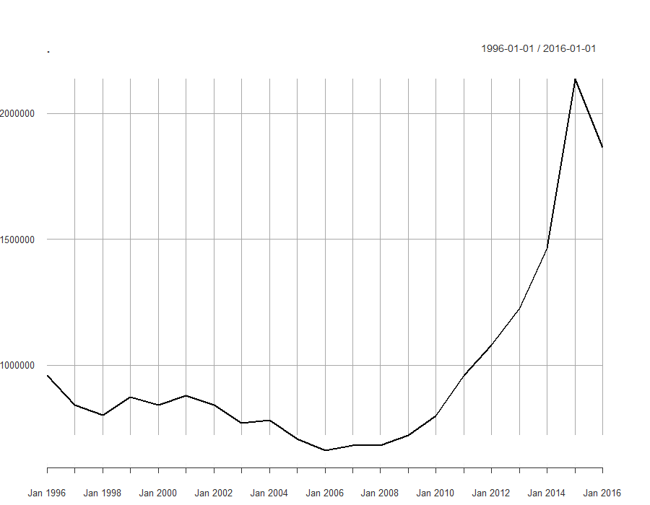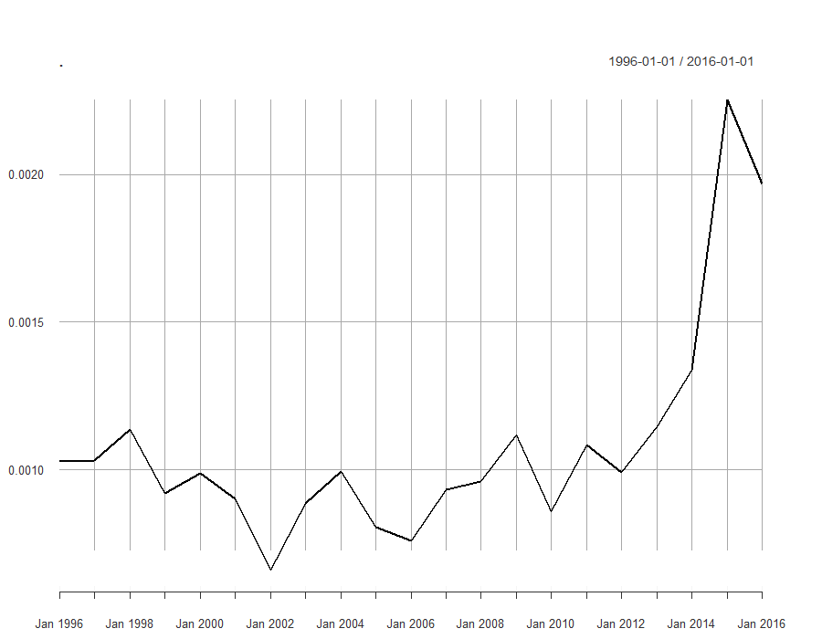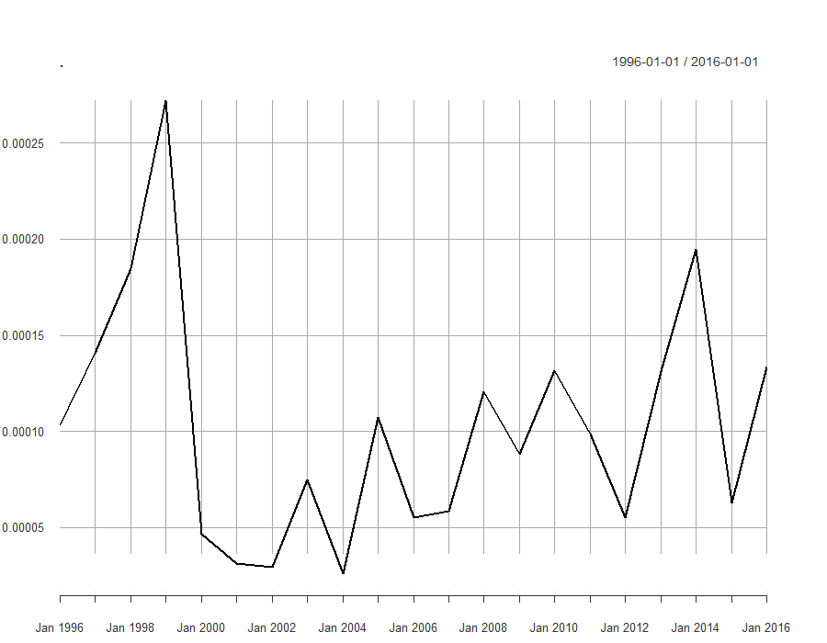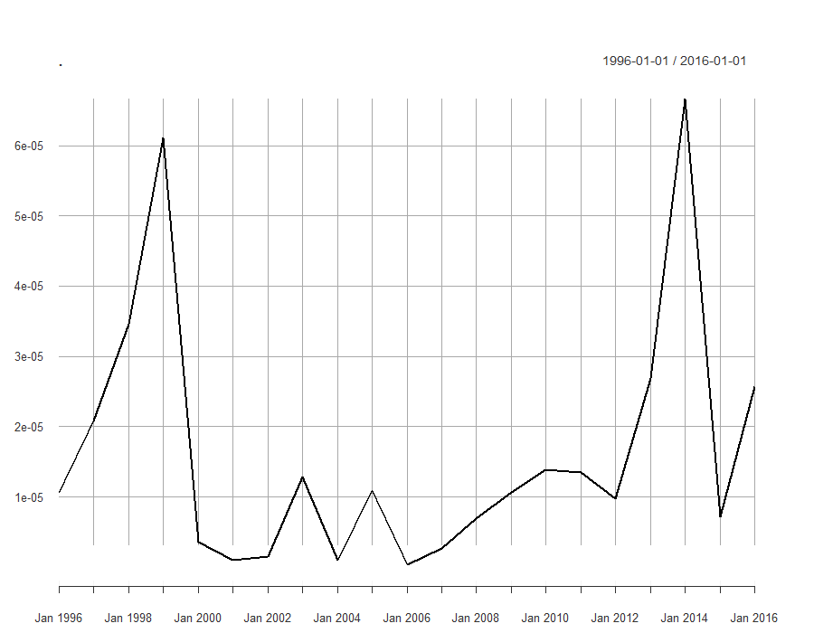
By comparing the curves one can see that the total immigration rate after 2012 exceeded the limit of one million immigrants per year, which was an often cited figure in daily news coverage and was framed with pictures of masses of human trespassing the EU-border land and the terms of “mass immigration”, “refugee crisis” or “refugee wave”. Former research had shown that this framing in news coverage had had a negative effect on citizens perceptions of and attitudes and behaviour towards immigrants.
In the context of Foreigners´ Policy, in 1998, the Anwerbestoppausnahmeverordnung was adopted to grand labour permits for highly skilled labour migrants. It was thus possible to increase high skilled migration though low skilled labour migration was restricted by the Anwerbestopp. Over the course of the law reform of the Citizenship Act in 2000, dual citizenship, as well as birth right citizenship were implemented, even though this right was restricted to the compulsory option model. It was argued that a dual national loyalty would not be indicative for integration, consequently nationality was strengthened. After Schröder´s campaign for a Green Card in 2000 this was adopted a few months later to further simplify high-skilled migration. After those intensive debates on qualitative aspects of immigration, like the questions about what groups of immigrants are desirable and what national belonging is like, these regulations were implemented. Later, in 2000, the Independent Commission on Immigration (named after its president Süssmuth-Kommission) took place, when an immigration law was firstly debated, after many years of high immigration to Germany and sessions of debating it.
Between 2003 and 2011 the debate about citizenship issues and also related to values associated with a German citizenship status increased. In Germany the Kopftuchdebatte took place in 2003 about whether an employment can be rejected if Muslim female teachers are wearing a hair scarf as a religious symbol. The Federal Constitutional Court had judged that a rejection is not admissible. Moreover, an amendment of the Anwerbestoppausnahmeverordnung was adopted to focus again on low skilled labour migration until 2004. In the course of the debate on low-skilled labour migration it was deliberated whether third state migrants could be recruited as seasonal workers. By adopting the law, it became possible to grant a three-month seasonal labour permit and the obligation to leave Germany after this period. In 2005 the Zuwanderungsgesetz and a regulation for third states regarding deportation and asylum rejection were adopted to amplify reasons for a deportation. In addition, in 2007 the amendment of the immigration law took place and the regulation on European Union citizenship was implemented. In other words, the citizenship concept as a whole had changed to a transnational model including the affiliation to the European Union. Consequently, it also excludes or restricts migrant groups from third states, especially low skilled workers and rejected asylum seekers. After this focus on other aspects of the Foreigners´ Policy field, in 2008 naturalisation tests were discussed and adopted to assess persons who want to apply for a German citizenship status. Residential issues were resolved in 2011 and subsequently reformed to differ between prisoners and persons in custody prior to deportation (Abschiebehaft). The issue of dual citizenship was deliberated in 2014 once more when the compulsory option model was repealed, and dual citizenship was liberalised. In 2015 the migration crisis as incident took place in Germany when chancellor Angela Merkel claimed “Wir schaffen das”. Following this incident various related laws were adopted named as Asylpaket I, as well as the Asylpaket II in 2016.
To conclude the general discourse of citizenship issues, one can see that dual citizenship is a phenomenon especially debated in the late 90s however it was also raised in 2014 when it was passed completely, and the compulsory option model was disestablished. Likewise, citizenship is a salient topic in the late 90s but the trend increased overtime since 2004, like the immigration rate does after 2006. The context of the citizenship discourse was about immigration in general and about restricting low-skilled, as well as stress high-skilled labour migration in detail. Furthermore, the discourse relates to religious values, European integration and its social membership, and deportation or exclusion of irregular migrants who are not accepted and are excluded from asylum by defining secure third states and further implementations for securitisation.

Party actors´ salience on citizenship
To amplify the time-series analysis now the focus is on parliamentary parties. Relative frequencies of citizenship queries do show substantive divergences between parties around 1996 to 1999 and 2008 and 2014 divergences in relative speech frequencies occur. The relative speech frequency is the proportion of all relevant search words sorted by parliamentary parties to the total corpus GermaParl. The y-axis in Figure 5 shows these relative frequencies which means the proportion of documents tagged with a query to the number of all documents. When the y-scale shows a scientific value of 1e-04 this means 0.0001 or one permille of all documents. This value is difficult to interpret because of the total number of tokens included in the corpus, likewise the value can be misinterpreted because of institutional aspects regarding the length of a session, special occasions like elections and fixed speaking times by proportion of seats in parliament, which can reduce the relative speech frequencies.
Figure 4 Relative frequencies of citizenship related words from dictionary between 1996 and 2016
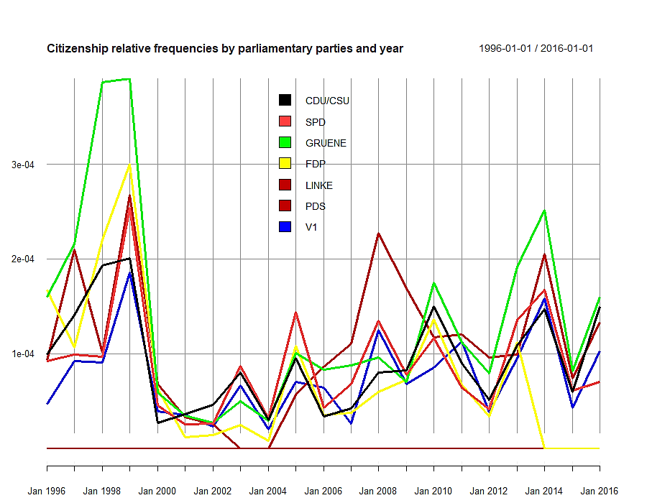
The actor´s relative speech frequencies regarding citizenship and dual citizenship (Figure 4 and 5) shows partly corresponding time series to the immigration rate in total (Figure 6) but with a time lag of about 5 to 7 years for the former period because of a higher number of immigration in 1991 (compare graphs in Figure 3).
Figure 5 Relative speech frequencies of dual citizenship related words from dictionary between 1996 and 2016
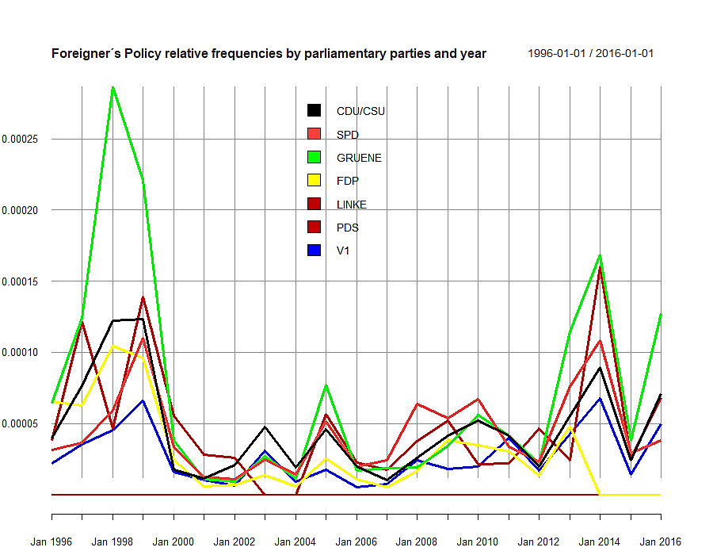
After 2002 the parliamentary discourse shows a positive trend in relative speech frequencies regarding citizenship. But one can also see that there is no stationarity of the function describing words related to citizenship because of increasing variance afterwards. On looking at the unique dual citizenship aspects without general citizenship and without Foreigners´ Policy one can see that the graphs are not too different from the general citizenship queries. Both queries show higher peaks around 1998, in 2005, 2010, and 2014. The frequencies decrease a little when the query only encloses dual citizenship search words, but the overall speech frequencies are quite the same as the overall citizenship queries, plotted in Figure 4.
By comparing the parliamentary parties, we can see convergences and divergences between them over time. When both incidents took place, the Greens had the highest relative speech frequencies regarding both citizenship in general and specifically dual citizenship (compare Figure 4 and 5). To get a closer imagination of the general discourse on citizenship a query was also made for the whole Foreigners´ Policy discourse, not only including search words from the policy field of citizenship like presented above. This query additionally includes trunced and regexed words regarding naturalisation, asylum and flight, deportation, resettlement, and family reunification to include this policy fields. In doing so, the graphs are directly comparable and the proportion of citizenship aspects to all Foreigners´ Politics will be visible. In figure 6 one can see that all graphs are raised on the y-axis. Additionally, the general distribution changed from a chaotic plot to a curve-linear function with approximating exponential growth after 2012.
Figure 6 Relative speech frequencies of Foreigners´ Policy related words from dictionary between 1996 and 2016
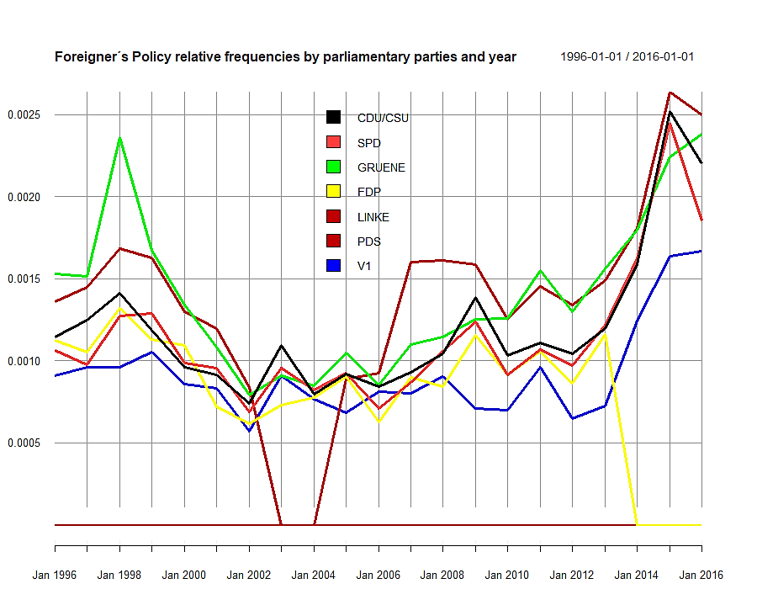
If one compares the parties for the overall Foreigners´ Policy discourse (Figure 6), one sees that regarding other aspects the relative speech frequency of the Greens and LINKE is also higher than the proportion of SPD and CDU/CSU in 1998 and nearly similar for 2015. This is conspicuous, the result of higher contextualisation by the Greens and LINKE because of different proportions of seats and regular scheduled speaking time relative to the quantity of seats in parliament likewise. This suggests that left-wing parties more frequently address citizenship and Foreigners´ Policy aspects than conservatives. In 2015 all parties represented in parliament address this issues. Similar to the raised graph, the relative frequency to all documents had increased to about 0.25 percent of total in 2015 and nearly 0.1 up to over 0.2 percent in 1998. After 2001 the frequencies decreased to its general minimum but also increased after 2002, indicating that to discussing citizenship issues after 9/11 was not appropriate.
In all three cases there are additional speakers in parliaments that are not tagged with a parliamentary group (V1) but also have relatively high speech proportions. Those ones can be governmental actors because they are institutionally defined as independent from members in parliament and parliamentary parties. After 2014 the proportion of the FDP is decreasing to zero, likewise in the case of PDS after 2002 and LINKE before 2007. Since the federal election took place in 2002 the PDS and 2013 the FDP did not achieve a mandate because of the election threshold (five percent hurdle). After the motion of confidence in chancellor Schröder failed, the election was accelerated in 2005 and both the FDP and PDS managed to get enough votes to move back to parliament. In 2007 the PDS became disorganised, changed later together with the WASG into the LINKE. After 2014 the FDP did not make it to the parliament.
Considering bivariate correlation between the total immigration rate and the dictionary queries, Pearson’s r can be used to describe an overall association (Field et al. 2012, 206; 214-223). To use also a conservative non-parametric measure Spearman´s ρ is additionally executed (Field et al. 2012, pp. 223–225). Thereby the immigration rate correlates with the political actors´ relative speech frequencies regarding citizenship aspects on a low level (r ≈.12; ρ ≈ .21). However, in about 61 percent of cases this is not the true value of correlation (p-value > .6138; for rho the p-value > .36). That is, a correct estimation for about 39 percent of cases can be assumed, in all other cases the correlation is over- or underestimated, respectively not necessarily different from zero. The correlation for dual citizen queries does show a higher correlation (r ≈.28; ρ ≈ .4) with the total immigration rate, however it is also not the true correlation in about 22 percent of cases (p-value > .2215; p-value > .069) because of under- and overestimation. Despite the correlation being estimated incorrectly in some cases it is a first impression of a potential linkage between a salience effect of the total immigration rate and the relative speech frequencies in parliament. If we consider that immigration is folded into different issues to regulate. In the case of the late 90s especially the number of naturalisations was significantly higher than in later decades, whereas since 2012 the number of asylum applications increased to a maximum in 2016. To check also the overall correlation, queries were also included to check the correlation of total immigration and issues of Ausländerpolitik. In this case the a significant and very high correlation of .90 (p-value < .000) (ρ ≈ .64; p-value > .001) exists. To consider the proportion of explained variance, R² is executed. For citizenship issues the immigration rate can explain 1.37 percent and for dual citizenship issues 7.76 percent of the variance. In both cases that is not necessarily correct and can be over or underestimated, especially the number of observations including only 21 years. Despite that the total immigration rate can explain 83.82 percent of total variance of the relative frequencies of Ausländerpolitik issues about the period of the last 20 years. Regarding the results from Spearman´s ρ one have to consider a slightly higher value of association for (dual) citizenship aspects and lower for Foreigners´ Policy.
A single query for issues of Ethnic German resettlers had shown that before the millennium the relative frequency was more than twice as high in comparison to issues of asylum and flight which significantly increased after 2012. Debates on migration in general can be observed throughout the whole period but also peak for the years 1998, 2000, 2005 and 2007/8, as well 2013. It is furthermore obvious that these issues were more often discussed by the Greens and PDS or LINKE. The naturalisation issue was unambiguously mostly discussed in 1999 and around 2008. Deportation and denaturalisation aspects were debated the whole period of observation, with higher rates in the 1990s and a high peak of the CDU/CSU group in 2009. At first sight it can be assumed that the CDU/CSU group responds less frequently to topics of immigration, naturalisation, as well as dual citizenship, whereas the other actors especially the Greens and PDS, respectively LINKE, address these issues more frequently.
Last, a simple moving average function was applied to detect similarity between the time series. The target is on the description of the time-series not on the inference of time lag effects. The data cannot be used to formulate an adequate and valid prediction model for further observations because of the rare period of annual data over 21 years (monthly data for immigration rates is not available), the trend in the data is not adjusted, and the speech frequencies do not fulfil the assumption of randomness because of institutional arrangements. Likewise, the high significant correlation implies this. Therefore, auto-correlation function (ACF) and partial ACF (PACF) cannot be used to formulate predictive models. As one can see in figure 7, the total immigration rate (top left), when it is smoothed about 10 lags (here years), is highly similar to the graph of the total Foreigners´ Policy speech frequencies (top right). As the correlation test has intended the citizenship speech frequency graph (bottom left), also smoothed over 10 years, is much different to the immigration rate graph. The same applies to the dual citizenship frequency graph (bottom right). Foreigners´ Policy is significantly highly correlated and shows a high synchrony over time. Both the correlation of frequencies and immigration rate and the synchrony of its time-series indicate that the immigration rate has a substantial effect on the salience of immigration as an important issue, so that the issue gets on agenda.

Figure 7 Smoothed average functions of total immigration rate, total Foreigners´ Policy field, citizenship, and dual citizenship (from top left to bottom right)
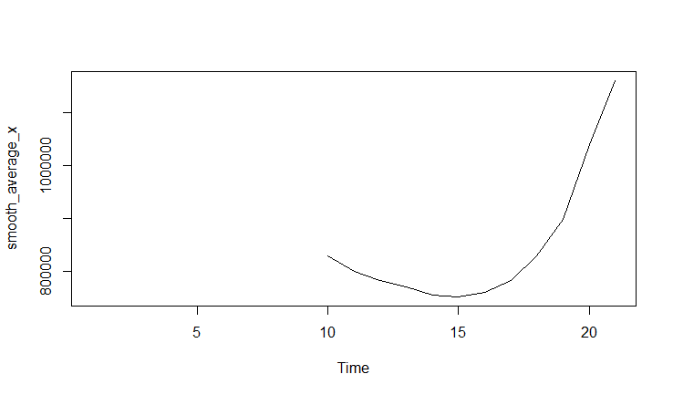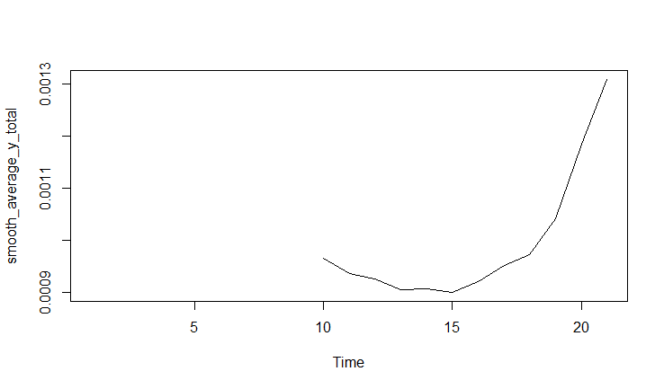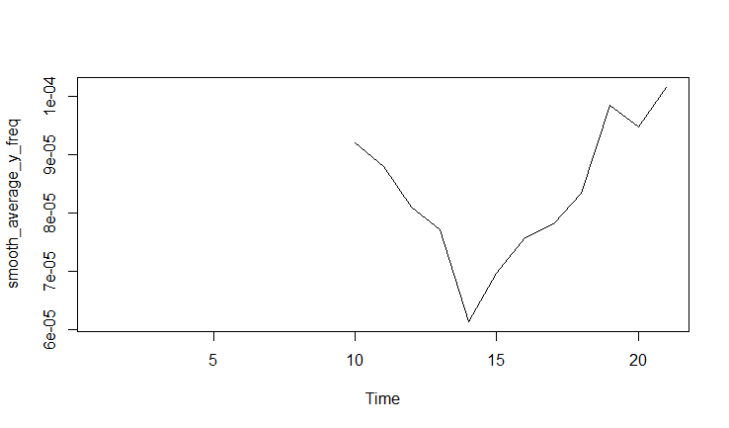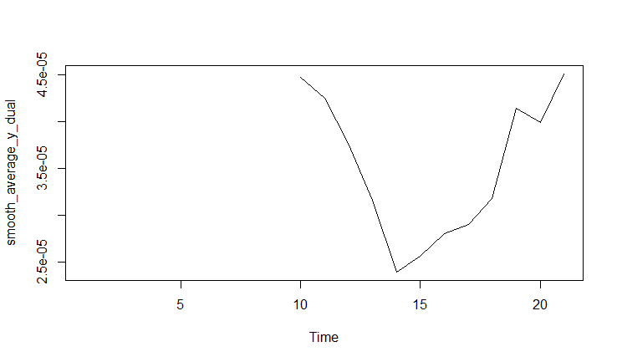

Parties’ linguistic context convergence
In the following the focus is on linguistic convergence aspects of parliamentary parties. All truncated lexemes regarding dual citizenship where analysed regarding their concordances by using kwic and their collocations to detect linguistic patterns. The results suggest that the language used in parliament is highly formal throughout all parties. Most often citizenship aspects are presented as nouns and constructed as n-grams like article-noun-combinations, article-adjective-noun-complexes, as well as article-noun-pronoun-(adjective)-noun-combinations. Likewise, it is a typical phenomenon that quotation marks or dashes are significant collocations of kwics. Parliamentary speakers have to place their speech within a usually long session about various topics, with many speakers. Moreover, this speaking time is highly restricted by the proportional sizes of parliamentary party groups. Furthermore, it is normal that political opponents use interjections for criticism or support, as well as they can ask questions or intervene. Following this highly ritualised logic of a speech the speaker has to refer to those other speakers and actors in the broader discourse or events. Speakers cite their opponents and supporters to strengthen their argumentation. Linguistically they often use rhetoric elements like prosodic characteristics of intonation and interpunction to attain the desired effect of a speech which increases the p-value for quotation marks and dashes. Also climaxes and relative clauses are popular. On looking at the content-related structure regarding citizenship the collocations show that most commonly parties speak about the same aspects (see Table 3).

Table 3 Collocations of '".*[Ss]taatsbürger.*"' between 1996 and 2000 by party (only similar ones)
 | CDU/CSU | SPD | GREENS | FDP | LEFTS
Collocations of '".*[Ss]taatsbürger.*"' | doppelte, doppelten, eine, Uniform, deutsche, deutscher, Beifall, der, das | Uniform, eine, doppelte, doppelten, deutsche, Reform, Beifall, deutschen, die, der, das | doppelte, doppelten, deutsche, Uniform, Beifall, Reform, die, deutscher | die, der, eine, doppelte, Uniform, deutsche, deutschen, die, das | doppelten, der, die, doppelte, Uniform, deutsche, das
For example, the term '".*[Ss]taatsbürger.*"' for instance is often used as a noun by all parties and mostly the lexemes [Staatsbürger], [Staatsbürgerschaft], as well as [Staatsbürgerschaftsrecht] or [-gesetz] are used. Significant collocations of these terms are mostly articles, adjectives, or relative pronouns. Prominent words are especially the adjective [doppelte(n)] and the noun [Uniform] and [Beifall]. The term [Uniform] often occurs because [Staatsbürger] is often contextualised with aspects of military service, which is one crucial topic regarding dual citizenship because of the critical aspects of state loyalty of a citizen who have a dual citizenship. Those citizens had had to fulfil their service in two states. Especially the CDU/CSU often use this argument against dual citizenship. After the rejection of the compulsory military service in Germany in 2011 this aspect has become increasingly irrelevant for argumentation though the loyalty argument remained in discourse.
The context of citizenship issues is additionally often related to dual citizenship aspects especially in the case of allochthone Germans with Turkish descent and foreigners´ integration. The qualitative validation had shown that the discourse on citizenship is usually related to dual citizenship aspects which increases the significance of [doppelte(n)]. In some cases [türkischen] was also a significant collocation of '".*[Ss]taatsbürger.*"'. The results have been validated qualitatively by a theoretical sampling by using the dictionary of dual citizenship and get the periods with high peaks (Förster 2016, p. 147). Out of the 91 unique speeches that were sampled, 86 unambiguous speeches referred to dual citizenship. The analysis implies a high convergence between speaker of the same parliamentary group. They often use the same stylistic devices, like rhetoric questions, parenthesis, and tense for strengthen the prosody. This is hardly surprising because of the obligation of united presence and argumentation of (parliamentary) parties that are strengthened in doing so. The CDU/CSU speakers for example often use a neural language, simple present and main clauses. They agitate with rhetoric questions. In the case of dual citizenship their argumentation is often linked to emotional dimensions of the nation state and a folk-perception of an introversively directed collective group and an exclusionary argumentation.
Nun zu Ihrem Antrag. Sie wollen die doppelte Staatsangehörigkeit für hier geborene Ausländer. Haben Sie denn gefragt, ob die Ausländer, zum Beispiel die türkischen Mitbürger, dies überhaupt wollen? Wollen Sie ihnen die doppelte Staatsbürgerschaft gegen ihren Willen aufdrängen? Ich frage weiter: Ist dies wirklich integrationsfördernd? Sie haben die Verpflichtung, dafür den Beweis zu erbringen. (Erwin Marschewski 1997-06-05 CDU speech on naturalisation and Citizenship Law reform)
Moreover, opposition parties have a remarkable criticising argumentation structure referring to governmental parties. Often individual cases, as well as theoretical or extreme cases, are used as examples to stress their own arguments during debates.
1997 habe ich, glaube ich, zum ersten Mal richtig verstanden, worum es bei dem Thema geht. Damals habe ich nämlich in den Vereinigten Staaten studiert, […]. Meine Gasteltern waren 1972 für ein knappes Jahr in Deutschland. Dort ist ihr Sohn auf die Welt gekommen, […]. Als es um die Ausweispapiere ging und meine Gast-eltern sich wieder nach Hause aufmachen wollten, gab es plötzlich ein Problem. Die deutschen Behörden haben nämlich gefragt: Was wollen Sie eigentlich von uns? Sie sind doch Amerikaner. Das ist ein amerikanisches Kind. - Die amerikanischen Behörden wiederum haben gefragt:
Was wollen Sie denn? Das Kind ist in Deutschland geboren. Es ist ein deutsches Kind. Das Beispiel zeigt: Wir haben unterschiedliche Traditionen. (Lars Castellucci 2015-04-23 SPD on immigration and dual citizenship)
One speaker notes that the debate on citizenship in general is often related to German and Turkish citizens and a potential dual citizenship for Turkish people. Especially this aspect in debate is conspicuous because for almost 20 years the CDU/CSU have been rejecting dual citizenship and have been supporting a restrictive compulsory option model. The case of German-Turkish citizens was used to argue for and against dual citizenship.
In dem letzten statistisch erfaßten Jahr ist bei den Türken - wir reden offenbar nur über Türken - unterm Strich ein Plus von 30 000 Menschen verzeichnet. Dazu gehören der Familiennachzug und auch die Asylbewerber; die meisten sind Kurden und haben die türkische Staatsbürgerschaft. (Cornelia Schmalz-Jacobsen 1997-10-30 FDP; German civil servants responsible for integration of foreigners)
Die Quote der akzeptierten Mehrstaatigkeit bei Einbürgerungen beträgt bundesweit über 53 Prozent. Bei türkischen Staatsangehörigen liegt sie bei nur 28 Prozent. Das heißt, Mehrstaatigkeit wird bei nichttürkischen Staatsangehörigen in Deutschland mehr als doppelt so häufig akzeptiert wie bei türkischen. (Sevim Dagdelen 2012-02-09 LINKE)
To sum up, convergences are especially linguistically given. All parties use a formal language and use equal references. The debate is consistently pointed at domestic politics and integrational aspects within the majority society. Exogenous factors are in the closer context given especially by citation of statistics on naturalisation applications, references to social consequences of guest worker politics and with that an increasing population of allochthon Germans especially from Turkey. After 2012 the context drifted to issues of increasing immigration, the now high population of second and third generation guest workers family members and the continually European integration and with that EU citizenship, as well as free movement within the European Union.

Parties´ linguistic context divergence
The last step of the analysis will focus on linguistic context divergences between parliamentary parties in Germany. The linguistic features were taken into account to detect differences in the use of language by parliamentary parties. First, the proportion of speaking time is highly restricted by institutional arrangements, consequently differences exists in this dimension. The time-series analysis shows that left-wing parties, particularly the Greens and LINKE does refer more frequently to citizenship and Foreigners´ Policy. Second, the communication strategy is deviant. The kwics shows, left-wing parties do more frequently use attributable lexemes more frequently, like [optionspflichtige] [Personen] and anthropomorphic lexemes, like [Optionspflichtige], [Staatsbürger], [Doppelstaatler]. The use of relative clauses with personal pronouns, prepositions and a conditional attributable language, climaxes, repetitions, and a high use of frames of discrimination of minorities is typically of left-wing parties or progressive ones, whereas the CDU/CSU and partly the FDP more frequently uses adjective-noun-complexes based on main clauses and citations, and neutral objective languages (see Table4).
Table 4 Collocations of '"[Mm]ehrstaat.*"' for 1996 to 2016 by party (partial low counts for LINKE and Greens; without duplicates)
 | CDU/CSU | SPD | GREENS | FDP | LEFTS
Collocations  of '"[Mm]ehrstaat.*"' | der, die, Vermeidung, " ", zuzulassen, generelle, eine, Ausnahme, Loyalitätskonflikten, muss, Optionszwang, vermeiden, Aufweichen, Grundsatz, akzeptieren, verankern, Staatsangehörigkeitsrechts, Ermöglichung, Abstriche | Hinnahme, hingenommen, von, unter, die, der, generelle, akzeptiert, von | Hinnahme, eine, Vermeidung, Grundsatz, soli, Lösungswege, hinnimmt, bewährte, Vorliegen, der, die, akzeptieren, bei | der, Vermeidung, die | Möglichkeit, Verengung, Türkinnen, Doppelpaß, eröffnen, Kreis, die, der, bei, in
Likewise, political opposition parties more frequently criticise governmental actors. First and foremost, the LINKE uses a critically agitating and often more colloquial language, whereas the Greens, FDP, and SPD use more describing or neutral elements and also technical languages.
Integration ist ein Anspruch und eine Anstrengung, zu der es keine Alternative gibt. Dies ist die Quintessenz des Memorandums meiner Vorgängerin im Amt der Ausländerbeauftragten, Frau Schmalz-Jacobsen. Ich möchte an das politische Vermächtnis, in dem sich übrigens alle meine Amtsvorgängerinnen und -vorgänger einig waren, anschließen: erleichterte Einbürgerung, rechtliche Gleichstellung und soziale Integration. Integration ist ein Anspruch und eine Anstrengung, zu der es keine Alternative gibt. (Marieluise Beck 1998-11-12 GRUENE)
Herr Mayer, die allermeisten in Deutschland lebenden Migrantinnen und Migranten sind loyaler gegenüber dieser Gesellschaft und dem Grundgesetz als der Nazimob, der Flüchtlinge durch die Straßen jagt und Unterkünfte in Brand steckt, oder CSU-Politiker, die über ministrierende, fußballspielende Senegalesen in unserer Gesellschaft schwadronieren. Das ist nicht loyal gegenüber unserer Gesellschaft, Herr Kollege Mayer. (UNDEF (probably Ulla Jelpke) 2016-09-23 LINKE)
The use of ideological frames was furthermore considered by classifing given sample documents, stated above, to estimate parties´ political viewpoints on transnational and national concepts of citizenship. The focus is on the argumentative structure or framing of dual citizenship issues. The classification reveals that progressive or left-wing parties usually use frames of transnational or multicultural ideology more often whereas the percentages of right-wing parties or conservatives are higher for a national ideology framing (see Table 5); and in one context even racist.
Table 5 classification scheme, adapted from Helbling (2012), own illustration
frame | Context | CDU/CSU | SPD | GREENS | FDP | LINKE
Identity | National | 83,72% | 6,522% | - | 16,667% | -
Identity | Transnational / multicultural | 16,279% | 93,478% | 100% | 83,333% | 100%
 | Total | 100% | 100% | 100% | 100% | 100%
That is the German parliamentary parties represent different viewpoints especially classified by conservative and progressive political programmes. The CDU/CSU advocates their viewpoint, consistently over time that integration should be an introversive process, and the focal point should be integrating foreigners who have been residing and living in Germany for a long period of time. In five speeches however progressive viewpoints can be found (Wolfgang Bosbach 1999; Peter Altmaier 1999; Helmut Brandt 2014; Michael Frieser 2014; Stephan Mayer 2014), which implicates that some members also support a modern interpretation of the nation state and its definition of a folk. The CDU/CSU defines its concept of integration in the light of a community of destiny but likewise conform to modern constitutional patriotism to guarantee a qualitatively high integration. At the same time the CDU/CSU claims that access to a German citizenship status thereby is restricted by accepting integration.
Integration heißt, sich mit diesem Land, mit seiner Geschichte, mit seiner Zukunft zu identifizieren. Integration heißt, Teil der Gesellschaft zu sein. Integration heißt, Rechte und Pflichten anzunehmen. Integration heißt, die deutsche Sprache zu sprechen. Integration heißt, sich mit unserer Gesellschaft und Verfassungsordnung zu identifizieren. Deshalb, meine Damen und Herren, kann Integration nicht alleine durch einen Hoheitsakt, nicht alleine durch die Übergabe des deutschen Passes erreicht werden. Die Staatsbürgerschaft steht am Ende und nicht am Anfang der Integration. (Jürgen Rüttgers 1998-11-12 CDU on dual citizenship and integration)
The progressive parties though saw the necessity to modernise the Citizenship Law to adjust it to former German specific developments.
Die Diskussion über die Neuregelung des Staatsangehörigkeitsrechtes tritt schon ziemlich lange auf der Stelle, eigentlich viel zu lange. Spätestens seit der Wiedervereinigung Deutschlands am 3. Oktober 1990 ist die Notwendigkeit einer zeitgemäßen Reform des deutschen Staatsangehöigkeitsrechtes unbestritten. (Fritz Rudolf Körper 1996-02-08 SPD)
Later, the European integration process consequences of European citizenship and transnational developments from increasing individual mobility across national borders were considered.
Die CDU kann nicht das Wort von der Globalisierung immer im Munde führen, wenn sie sich auf der anderen Seite den Realitäten eines modernen Staatsbürgerschaftsrechts verschließt. Sie fordern einerseits flexiblere Arbeitsmärkte und auch eine größere grenzüberschreitende Mobilität, andererseits beharren Sie aber auf dem Blutrecht als Grundlage für die Staatsangehörigkeit. Globalisierung relativiert die Nationalstaatlichkeit, was allerdings neues Denken im Staatsbürgerschaftsrecht erfordert. Ich empfehle den Blick über die Grenzen. (Marieluise Beck 1998-11-12 GRUENE)
Two different viewpoints exist. On the one hand the emotional conviction that historical values of a state, as a community of destiny, have to be preserved, and on the other hand a rational focus on modern conditions of a globalised world.
Sie müssen sich doch die Frage gefallen lassen, warum wir ausgerechnet in dieser Frage von dem europäischen Gleichklang abweichen wollen, warum wir nicht nur der europäischen Entwicklung nicht folgen, sondern geradezu schnurstracks ins 19. Jahrhundert zurückgehen wollen. Diese Frage müssen Sie beantworten. Wir stellen sie doch nicht nur im Interesse der einzubürgernden Ausländer - um deren Einbürgerung zu erleichtern -, sondern auch im Interesse unseres eigenen Volkes, damit das Anwachsen einer Diaspora von Bürgern zweiter Klasse in unserem Lande verhindert wird. (Burkhard Hirsch 1996-02-08 FDP on dual citizenship and the European integration)
The conservative focus is on differences between states and its societies and the belonging of individual citizens to collective, that is, its perceptions of community. The progressive focus is on international law of equal status and individual rights of independent persons.
Herr Röspel, wenn Sie die Situation im Verhältnis zwischen Deutschland und Schweden, also zwischen zwei EU-Staaten, mit der Situation zwischen Deutschland und der Türkei vergleichen und sagen: " Das verstehe ich nicht ", dann verstehe ich Sie nicht. Deutschland und Schweden sind Mitglieder in der Europäischen Union; sie gehören also zu einer europäischen Werteunion. Das, was zurzeit in der Türkei passiert, hat mit den Werten der Europäischen Union nichts zu tun. Deshalb ist es in Ordnung, eine doppelte Staatsbürgerschaft im Zusammenhang mit Schweden zu haben, aber nicht, schon gar nicht in der aktuellen Situation, mit der Türkei.
Die Türkei gehört nicht zur EU. Das ist ein gewaltiger staatsrechtlicher und völkerrechtlicher Unterschied. Nehmen Sie das bitte zur Kenntnis! (Reinhard Grindel 2013-06-05 CDU on integration of people with migration background)
In the 90s the FDP had therefore introduced the compulsory option model to find a compromise between these different viewpoints of community and integration. The FDP wanted to bring forth the debate on dual citizenship and a modernisation of the German Nationality Law, hence, the FDP group was willing to accept a compulsory option to implement a first jus soli regulation in addition to the archaic jus sanguinis.
Dabei ist die FDP durchaus bereit, über die vermehrte Hinnahme der doppelten Staatsangehörigkeit nachzudenken und in diese Richtung zu gehen. Aber wir sind uns auch bewusst, liebe Kollegen von den Grünen, dass die Staatsangehörigkeit für den Erfolg von Zuwanderung und Integration nicht primär entscheidend ist, sondern die persönliche und berufliche Perspektive der Menschen, die nach Deutschland kommen. Das ist entscheidend, damit sie hierbleiben wollen. […] Das Optionsmodell war damals ein von der FDP vorbereiteter Kompromiss, um zwischen Rot-Grün und dem Bundesrat endlich weiterzukommen. Vor vier Jahren haben wir in der Koalition die sinnvolle Vereinbarung getroffen, erst einmal Erfahrungen zu sammeln, wie sich diese Regelungen auswirken, und danach zu schauen, wie wir damit umgehen. Alles andere wäre wohlfeiler Aktionismus gewesen. Jetzt erst kommen die ersten Jahrgänge tatsächlich in die Entscheidungsphase. Die bisher gesammelten Daten - der Herr Staatssekretär hat sie vorgetragen - bestätigen unser Vorgehen. Gleichwohl heißt es, nicht wegzusehen und die Augen nicht vor der Realität zu verschließen. Deshalb wollen die Liberalen eine Modernisierung des Staatsangehörigkeitsrechts. Aber wir bestehen darauf - anders als es sich zum Teil bei Vorschlägen der Opposition darstellt -, dies nicht gedankenlos, nicht ohne Augenmaß und nicht ideologisch anzugehen. (Hartfrid Wolff 2013-06-05 FDP on the motion of Citizenship Law reform from the SPD)
Concluding, the left-wing parties in German parliament are more willing to accept social conditions and to adapt regulations to new situations and social conditions. Likewise, they want to incentivise individuals to naturalise by deregulation and promotion in this policy field to support a transnational community and citizens who actually live in those transnational conditions. On the other hand, right-wing parties want to regulate and restrict the access to naturalisation, as well they refuse to accept dual citizenship coming from perceptions of nationality and a loyal belongingness to a collective, that is they accept the compulsory option model since an individual has to choose a collective and indicate his or her belongingness. The CDU/CSU thereby contextualises and strengthens their viewpoints with an objective language, whereas the left-wing actors emphasise the individual rights and criticise the archaic nationality perception of emotional belongingness and loyalty especially with their agitating and differentiating language.

Implications
Regarding the first research question it can be said from a general perspective that debating citizenship issues had changed over the whole period between 1996 and 2016. One can see that citizenship issues were more often addressed in the late 1990s and between 2012 and 2015. Dual citizenship aspects are simultaneously addressed, however general citizenship aspects are discussed less frequently after 2012. It could be shown that the reform procedure is distributed over 20 years but parties´ argumentation had not changed substantially. In the time between 2000 and 2012 the topic of citizenship was far less debated in parliament than in former times. Thereby, left party actors especially the Greens, PDS, and LINKE show higher frequencies of references to the citizenship discourse and to dual citizenship than other parliamentary parties. Before the millennium, the issue of Aussiedler and the integration of former guest worker families had been debated more frequently, which then shifted to asylum issues, immigration, and the recognition of EU regulations on dual citizenship and related transnational conditions.
Considering the second research question how the total immigration rate corresponds to the discourse on citizenship, it can be shown that immigration is linked to the discourse on citizenship but not in every case. It is a necessity to distinguish between the type of immigration or the crucial aspects. Results from the first step respectively the first hypothesis show that the immigration rate significantly highly correlates with the relative speech frequencies of terms related to the whole field of Foreigners´ Policy though not significantly with (dual) citizenship related issues. The assumption that immigration rate and speech frequencies referring to citizenship issues are positively correlated is true but insignificant. Here a look on the naturalisation statistics and for later times on the asylum applications statistics stresses the assumption of a discursive drift. The hypothesis must be rejected, though. The time series analysis shows that the immigration rate graph and the graph of Foreigners´ Policy smoothed over 10 years is highly synchronic, the graphs for (dual) citizenship are only after 2012 parallel in slope. However, neither citizenship nor dual citizenship aspects are significantly correlated with the immigration rate. The qualitative analysis shows that partial aspects from immigration dynamics affect the contextualisation in speeches substantially. The social conditions after 2012 have changed compared to the situation before 2000. Immigration became a salient topic in the German society and in parliamentary speeches, as well as the percentages of both the population of foreigners and of people with migration background have increased since 2012. An increasing allochthone German population is consequently a substantive social condition (Oberndörfer 2001, p. 28) and an argumentation of a community of destiny becomes likewise a more or less freely chosen community of option.
The second step of analysis had focused on parliamentary parties´ linguistic contextualisation. All parties use typical linguistic devices of the political toolbox of rhetoric, like climaxes, repetitions, and citations. Its language targets on strengthening the own arguments and undermining the opponents´ arguments. Political parties in Germany use a formal and generally neutral language, which is generally regarded as polite. The classified contexts imply that the conservative parliamentary parties, such as the CDU/CSU, use national and value related frames in their contextualisation of dual citizenship much more frequently. Likewise, much more critical towards Germans with Turkish descents, in one case in 1998 even racist. The CDU/CSU thereby contextualises their arguments objectively and clearly and they refer to juridical conditions and emotional aspects, values, and a national identity. Progressive parliamentary party actors use transnational or multicultural frames more often and refer to humanitarianism and discrimination issues. Their language is more conditional and differentiating, often more describing, as well as agitative and attributive. The use of relative clauses is more common, whereas conservative parties often use main clauses. The Greens use technical language more frequently, whereas the LINKE often uses colloquial terms. Moreover, the FDP uses the most objective language containing more article-noun constructions and references to legal aspects. The SPD uses describing formulations and anthropomorphic formulations more frequently. The results regarding relative frequencies of national and transnational frames shows that conservative parties use national contextualisation much more often than progressive parties and vice versa. The second hypothesis consequently can be accepted.
Discussing the third research question, to what extend imaginations of dual citizenship differ between parliamentary groups, left party actors refer more frequently to (dual) citizenship aspects than conservative ones and criticise the governmental parties especially the parliamentary majority of the CDU/CSU. The FDP generally seek to avoid dual citizenship but excepts realities. All progressive parties prefer a model of dual citizenship to accept and reflect given social conditions of a high population of allochthone Germans and also European Union membership and citizenship. This conforms to former results from Green (2004, p. 101). They also support forcing an increase in naturalisations, whereas the CDU/CSU do prefer lowering them. It is understandable that progressive parties criticise the small number of naturalisation in Germany given the high number of foreigners living in Germany, as well as the demography and labour market situation. The regulations preferred by the CDU/CSU restrict naturalisation application, immigration in general and demands a clear statement of loyalty by persons who want to apply for a German citizenship as it is founded on national perceptions of belongingness by nationality. The LINKE criticises especially the CDU/CSU consistently over time and persists that the CDU/CSU forces a discriminating policy programme by excluding migrant groups, as well as the allochthone population, particularly of Turkish descent. The FDP had used the citizenship law reform to introduce the compulsory option model to compromise between two diverging viewpoints on immigration and integration policy. Dual citizenship is a phenomenon especially debated in the late 90s when it was firstly implemented. However, it has also been raised in 2014 when it was completely passed. For the disestablished compulsory option model on behalf of children that were born in Germany the option model remains for foreign-born Germans and confirms to the theoretical assumptions of an exclusionary policy. This long period of critically discussing this issue demonstrates how different the ideological perspectives between political actors is. A general change in discourse is visible when in additional to the citizenship policy field those from Foreigners´ Policy are considered. It is obvious thus that the agenda had shifted from the Ethnic German resettlers topic and accepting social conditions of allochthone German families with transnational living conditions, as well as implementing dual citizenship to the topics of problems of asylum and flight, the topic of immigration, and implementing European Union regulations. For other topics of Foreigners´ Policy became increasingly significant citizenship is an often-referred policy field in the whole discourse likewise. Regarding new dynamics of migration and integration in Europe and especially in the case of Germany one has to consider citizenship issues as a crucial regulative concept for inclusion and exclusion of various social groups. Mostly focusing on integration of the majority and exclusion of minorities, as well as integrating residing individuals and exclude non-residing ones. The concept of integration presented by the CDU/CSU conforms to the Basic Law and claims especially the use of the German language and German values. The progressive parties provoke a naturalisation campaign which affects an increasing number of applications. Opportunities for integration and social participation are specially given by the implementation of naturalisation incentives and additional learning courses for learning the language, the culture, and institutional order aspects of the Federal Republic of Germany, as well as its constitutional values. Even though German parliamentary parties have dividing point of views on the concept of citizenship they still agree on the stated aspects of strengthening integration by supporting language learning and civil participation based on the values of the Basic Law, likewise the number of naturalisation applications in Germany are very low (Diehl and Blohm 2008, p. 440, BiB BUND 2019). A compromise in the aspect naturalisations is possible if the focus will be laid on promoting naturalisations for skilled persons and residential foreigners particularly in Germany. Especially this case is a high opportunity for a positive development.

Conclusion and Limitations
The aim of the analysis was to analyse German parliamentary parties´ linguistic and ideological contextualisation of citizenship issues within a broad and a narrow context. By using descriptive time-series analysis a significantly high correlation between the total immigration rate and speech frequencies regarding Foreigners´ Policy can be confirmed, despite the total immigration rate and (dual) citizenship aspects being positively but not highly associated with a huge uncertainty. Furthermore, the graphs of immigration rate and speech frequencies of Foreigners´ Policy are highly synchronic when their average is smoothed about ten years. The frequency graph of (dual) citizenship however is not synchronic. This result is restricted by lag of data for years before 1996 and after 2016.
Significant convergences in linguistic contextualisation of citizenship issues exist between parliamentary parties regarding their use of formal language, lexemes, and general sentence structure. However, nuanced differences exist regarding their semantic use of some aspects of citizenship like adjective forms and also linguistic devices. Particularly the ideologic framing of dual citizenship aspects differ between conservative and progressive parties. The analysis had helped to deduce given political argumentation on social integration of the increasing allochthone population of upcoming post-migration generations, and to classify potential conservative backlashes to concepts of an exclusive nation state.
The Limitations of this analysis include mainly problems in natural language processing. Because of double meanings or the contextuality some potential search words had to be excluded. For example, the query of [Identität] or [Loyalität] does not uniquely refer to aspects of identity in the context of citizenship, but also political identity, religious identity, political loyalty, and group affiliation. These dimensions cross the dimension of citizenship because citizenship consists as a part of the concept of group affiliation, the belonging to a state and its society. Those query words with a double meaning or ambiguous meaning regarding citizenship aspects had to be excluded or only used as exact lexeme like [Loyalitätskonflikt] because of the aim to reduce the bias from overestimation by count false-positive frequencies which would inflate the p-value.
It is recommended to conduct further research regarding immigration rate effects on discourse. Especially, the time series analysis had revealed that those incidents are highly associated with issue salience, which can thus affect the parliamentary discourse as an exogenous factor. Subsequently, it is necessary to examine the analysis on regional state level (Länderebene), in other European states and to look after periodicity by implementing former and later plenary protocols to formulate prognostic models. The micro level has to be taken into account to analyse whether the given convergences and divergences found on Bundesebene are different on Länderebene especially in light of the competence for integration policy on regional state level. The concluding remark remains on the question whether the association and contextualisation differ on Länderebene or other states.

References
Algan, Y., et al., eds., 2012. Cultural Integration of Immigrants in Europe. 2nd ed. Oxford, UK: Oxford Univ. Pr.
Bade, K.J. and Oltmer, J. Flucht und Asyl seit 1990 [online], bpb. Available from: http://www.bpb.de/gesellschaft/migration/dossier-migration/56443/flucht-und-asyl-seit-1990 [Accessed 17 Apr 2019].
Baker, P., 2006. Using Corpora in Discourse Analysis. London, New York: Continuum.
Baker, P., et al., 2008. A useful methodological synergy?: Combining critical discourse analysis and corpus linguistics to examine discourses of refugees and asylum seekers in the UK press. Discourse & Society, 19 (3), 273–306.
BAMF, 2019a. Anzahl der Asylanträge (Erstanträge) in Deutschland von 1991 bis 2019 [online], Statista GmbH. Available from: https://de.statista.com/statistik/daten/studie/154286/umfrage/asylantraege-erstantraege-in-deutschland-seit-1995/.
BAMF, 2019b. Anzahl der Zuwanderer nach Deutschland von 1991 bis 2017 [online], Statista GmbH. Available from: https://de.statista.com/statistik/daten/studie/28347/umfrage/zuwanderung-nach-deutschland/ [Accessed 9 Jul 2019].
Bennett, C. and Howlett, M., 1992. The lessons of learning.: Reconciling theories of policy learning and policy change. Policy Sciences, 25, 275–294.
Berry, M., Garcia-Blanco, I., and Moore, K., 2016. Press coverage of the refugee and migrant crisis in the EU: A content analysis of five European countries. [Project Report]. Geneva: UNHCR.
BiB BUND, 2019. Eingebürgerte und Einbürgerunsquote in Deutschland 1990 bis 2016 [online]. Available from: https://www.bib.bund.de/DE/Fakten/Fakt/M35-Einbuergerungen-ab-1990.html [Accessed 9 Oct 2019].
Blaette, A., 2016. polmineR.
Blickle, P., et al., 2015. Es brennt in Deutschland. Zeit Online [online], 3 Dec. Available from: https://www.zeit.de/politik/deutschland/2015-11/rechtsextremismus-fluechtlingsunterkuenfte-gewalt-gegen-fluechtlinge-justiz-taeter-urteile [Accessed 9 Jul 2019].
Bloemraad, I., Korteweg, A., and Yurdakul, G., 2010. Staatsbürgerschaft und Einwanderung: Assimilation, Multikulturalismus und der Nationalstaat. In: G. Yurdakul and Y.M. Bodemann, eds. Staatsbürgerschaft, Migration und Minderheiten: Inklusion und Ausgrenzungsstrategien im Vergleich. Wiesbaden: VS Verlag für Sozialwissenschaften / GWV Fachverlage GmbH, Wiesbaden, 13–46.
BMI Bund, 2019a. Einbürgerung [online], Bundesministerium des Innern, für Bau und Heimat. Available from: https://www.bmi.bund.de/DE/themen/verfassung/staatsangehoerigkeit/einbuergerung/einbuergerung-node.html [Accessed 8 Jul 2019].
BMI Bund, 2019b. Staatsangehörigkeit [online], Bundesministerium des Innern, für Bau und Heimat. Available from: https://www.bmi.bund.de/DE/themen/verfassung/staatsangehoerigkeit/staatsangehoerigkeit-node.html;jsessionid=AE97B9769E479B9D3D9C80D1B5A62BCA.1_cid287 [Accessed 8 Jul 2019].
Bommes, M., 2000. Migration und Lebenslauf: Aussiedler im nationalen Wohlfahrtsstaat. Sozialwissenschaften und Berufspraxis, 23 (1), 9–28.
Boomgaarden, J.G. and Vliegenthart, R., 2009. How news content influences anti-immigration attitudes: Germany, 1995-2005. European Journal of Political Research (48), 516–542.
Borttscheller, R.H., 2001. Die ausbleibende Integration: Politische und gesellschaftliche Folgen von doppelten Staatsbürgerschaften als Regelfall. In: H. Koschyk and R. Stolz, eds. Alte und neue Deutsche?: Staatsangehörigkeits- und Integrationspolitik auf dem Prüfstand. München: Hanns Seidel Stiftung e.V., 15–18.
Bos, L., et al., 2016. It´s the frame that matters: Immigration and media framing effects in the Netherlands. International Journal of Intercultural Relations [online], 55, 97–108. Available from: http://dx.doi.org/10.1016/j.ijintrel.2016.10.002.
bpb, 2018. Die soziale Situation in Deutschland: Bevölkerung mit Migrationshintergrund. In absoluten zahlen, Anteile an der Gesamtbevölkerung in Prozent, 2017 [online]. Available from: https://www.bpb.de/nachschlagen/zahlen-und-fakten/soziale-situation-in-deutschland/61646/migrationshintergrund-i [Accessed 22 Jul 2019].
BRD, 1990. Gesetz zur Regelung des Aufnahmeverfahrens für Aussiedler: Aussiedleraufnahmegesetz - AAG.
Brettschneider, F., 2007. Die Bundestagswahl 2005: Analysen des Wahlkampfes und der Wahlergebnisse. Wiesbaden: VS, Verl. für Sozialwiss.
Brettschneider, F., Niedermayer, O., and Weßels, B., 2007. Die Bundestagswahl 2005: Analysen des Wahlkampfes und der Wahlergebnisse. Wiesbaden: VS Verlag für Sozialwissenschaften / GWV Fachverlage GmbH, Wiesbaden.
Brouwer, J., van der Woude, M., and van der Leun, J., 2017. Framing migration and the process of crimmigration: A systematic analysis of the media representation of unauthorized immigrants in the Netherlands. European Journal of Criminology, 14 (1), 100–119.
Brubaker, R., 1992. Citizenship and nationhood in France and Germany. Cambridge, Mass. u.a: Harvard Univ. Press.
Bubenhofer, N., 2006. Einführung in die Korpuslinguistik: Praktische Grundlagen und Werkzeuge [online]. Zürich, Mannheim, Dresden, ZHAW Zurich University of Applied Sciences. Available from: https://www.bubenhofer.com/korpuslinguistik/kurs/index.php?id=statistik_signifikanzLLR.html [Accessed 8 Jun 2019].
Budge, I., 2015. Issue Emphases, Saliency Theory and Issue Ownership: A Historical and Conceptual Analysis: [Abstract]. West European Politics, 38 (4), 761–777.
Burke, E., Canavan, F., and Payne, E.J., 1999. Select works of Edmund Burke: A new imprint of the Payne edition. Indianapolis, IN: Liberty Fund.
Carrera, S., 2006. A Comparison of Integration Programmes in the EU.: Trends and Weaknesses.
Castles, S., Haas, H. de, and Miller, M.J., 2014. The age of migration: International population movements in the modern world. 5th ed. Basingstoke [u.a.]: Palgrave Macmillan.
Cerna, L., 2013. The nature of policy change and implementation: A review of different theoretical approaches [online], OECD [Accessed 8 Jun 2019].
Coleman, J.S., 1994. Foundations of social theory. Cambridge, Mass.: Belknap Press of Harvard Univ. Press.
Currle, E. and Wunderlich, T. Deutschland - ein Einwanderungsland?: Rückblick, Bilanz und neue Fragen. In: eBook-Paket Best of Lucius & Lucius. Berlin, Boston: De Gruyter Oldenbourg.
Decker, O. and Brähler, E., 2016. Autoritäre Dynamiken: Ergebnisse der bisherigen "Mitte"-Studie und Fragestellung. In: O. Decker, J. Kiess, and E. Brähler, eds. Die enthemmte Mitte: Autoritäre und rechtsextreme Einstellung in Deutschland/Die Leipziger Mitte-Studie 2016: Psychosozial-Verlag, 9–22.
Decker, O., Kiess, J., and Brähler, E., eds., 2016. Die enthemmte Mitte: Autoritäre und rechtsextreme Einstellung in Deutschland/Die Leipziger Mitte-Studie 2016: Psychosozial-Verlag.
Di Gregorio, A., 2018. Democratic transition and linguistic minorities in Estonia and Latvia: In-depth analysis. [Brussels]: European Parliament.
Diehl, C. and Blohm, M., 2008. Die Entscheidung zur Einbürgerung: Optionen, Anreize und identifikative Aspekte. In: F. Kalter, ed. Migration und Integration. Wiesbaden: VS Verlag für Sozialwissenschaften / GWV Fachverlage GmbH, Wiesbaden, 437–464.
Dolezal, M., et al., 2014. How parties compete for votes: A test of saliency theory: [Abstract]. European Journal of Political Research, 53 (1), 57–76.
DWDS, 2019. Nation [online], Digitales Wörterbuch der deutschen Sprache. Available from: https://www.dwds.de/wb/Nation [Accessed 1 Jul 2019].
Dzankic, J., 2016. Migration, citizenship and post-national membership. In: A. Triandafyllidou, ed. Routledge Handbook of Immigration and Refugee Studies. New York, NY: Routledge, 163–168.
Entman, R., 1993. Framing: Towards clarification of a fractured paradigm. Journal of Communication, 43 (4), 51–58.
Ersanilli, E. and Koopmans, R., 2010. Rewarding integration?: Citizenship regulations and the socio-cultural integration of immigrants in the Netherlands, France and Germany. Journal of Ethnic and Migration Studies, 36 (5), 773–791.
Espiritu, Y.L., 2013. Panethnicity. In: S.J. Gold and S.J. Nawyn, eds. The Routledge International Handbook of Migration Studies. Oxfordshire: Routledge; Taylor & Francis, 239–249.
Esser, H., 1993. Soziologie.: Allgemeine Grundlagen. Frankfurt a. M.: Campus Verl.
Extra, G. and Spotti, M., 2009. Language Testing, Migration and Citizenship: Cross-national perspectives on integration regimes. London: Continuum.
Faist, T. and Gerdes, J., 2008. Dual citizenship in an age of mobility. Washington DC: Migration Policy Institute.
Federal Statistical Office, 2019. Jede vierte Person in Deutschland hatte 2018 einen Migrationshintergrund.
Fedyuk, O., 2016. Transnational parenthood. In: A. Triandafyllidou, ed. Routledge Handbook of Immigration and Refugee Studies. New York, NY: Routledge, 145–152.
Field, A., Miles, J., and Field, Z., 2012. Discovering statistics using R. Los Angeles, London, New Delhi, Singapore, Washington, DC: Sage.
Förster, A., 2016. Der Folterdiskurs in den deutschen Printmedien. In: M. Lemke and G. Wiedemann, eds. Text Mining in den Sozialwissenschaften: Grundlagen und Anwendungen zwischen qualitativer und quantitativer Diskursanalyse. Wiesbaden: Springer VS, 139–166.
Foucault, M., 2016. Überwachen und Strafen: Die Geburt des Gefängnisses. 16th ed. Frankfurt am Main: Suhrkamp.
Foucault, M., 2017. Die Ordnung der Dinge: Eine Archäologie der Humanwissenschaften. 24th ed. Frankfurt am Main: Suhrkamp.
Geißler, R. and Pöttker, H., 2006. Integration durch Massenmedien: Medien und Migration im internationalen Vergleich Media and Migration: A Comparative Perspective. s.l.: transcript Verlag.
Goerres, A., et al., 2016. The Social, Economic and Political Origins of Local Political Elites in North-Rhine Westphalia in 2015: Results from a Telephone Survey of Members of 10 Local Councils. SSRN Electronic Journal.
Goerres, A., Spies, D.C., and Mayer, S.J. Deutsche mit Migrationshintergrund bei der Bundestagswahl 2017: Erste Auswertungen der Immigrant German Election Study zu Deutschtürken und Russlanddeutschen.
Green, S., 2004. The politics of exclusion: Institutions and immigration policy in contemporary Germany. In: C. Jeffery and C. Lees, eds. Issues in German Politics. Manchester: Manchester University Press.
Gries, T.S., 2009. Quantitative Corpus Linguistics with R: A Practical Intoduction: Taylor & Francis.
Grunau, A. and Bierbach, M., 2017. Immigrant voters in German federal election could prove influential. DW [online], 7 Sep. Available from: https://p.dw.com/p/2jSbH [Accessed 22 Jul 2019].
Hädicke, R., 2016. Sicherheit und Freiheit: Mediale Wert-Diskurse im Angesicht terroristischer Bedrohung. In: M. Lemke and G. Wiedemann, eds. Text Mining in den Sozialwissenschaften: Grundlagen und Anwendungen zwischen qualitativer und quantitativer Diskursanalyse. Wiesbaden: Springer VS, 167–194.
Hagan, J.M., 2013. Religion on the move: The place of religion in differnt stages of the migration experience. In: S.J. Gold and S.J. Nawyn, eds. The Routledge International Handbook of Migration Studies. Oxfordshire: Routledge; Taylor & Francis, 260–268.
Hammar, T., 1985. Dual citizenship and political integration. The International Migration Review, 19 (3), 438–450.
Han, P., 2005. Soziologie der Migration. 2nd ed. Stuttgart: Lucius & Lucius Verlagsgesellschaft mbH Stuttgart.
Hansen, G., 2001. Die Deutschmachung: Ethnizität und Ethnisierung im Prozess von Ein- und Ausgrenzungen. In: G. Hansen, R. Pfundtner, and N. Wenning, eds. Lernen für Europa. Münster/ New York/ München/ Berlin: Waxmann Verlag GmbH.
Hasse, A., et al., 2014. Entsteht linguistische Salienz im Gehirn? [series of lectures]: University of Zurich.
Helbling, M., 2012. Framing Immigration: Varieties of Arguments, Actors and Opportunity Structures. SSRN Electronic Journal.
Helbling, M., 2013. Validating integration and citizenship policy indices. Comparative European Politics, 11 (5), 555–576.
Helbling, M., 2014. Framing Immigration in Western Europe. Journal of Ethnic and Migration Studies, 40 (1), 21–41.
Helfer, L., 2016. Media effects on politicians: An individual-level political agenda-setting experiment. The International Journal of Press/Politics, 21 (2), 233–252.
Hettler, Y., 2014. Salienz, Bewertung und Realisierung regionaler Sprachmerkmale in Bremen und Hamburg. Dissertation. Georg-Olms-Verlag.
Hoffmann, W., Dose, N., and Wolf, D., 2015. Politikwissenschaft. 3rd ed. Konstanz und München: UTB.
Hunger, U., 2014. Migrations- und Integrationspolitik im europäischen Vergleich: Jahrbuch Migration - Yearbook Migration 2012/2013. Berlin [u.a.]: LIT.
Ignatow, G. and Mihalcea, R.F., 2017. Text mining: A guidebook for the social sciences. Los Angeles, London, New Delhi, Singapore, Washington DC, Melbourne: Sage.
Jacobs, D. and Rea, A., 2007. The end of national models? Integration courses and citizenship trajectories in Europe. International Journal on Multicultural Societies (IJMS), 9 (2), 264–283.
Jacobson, K., 2014. Livelihoods and forced migration. In: E. Fiddian-Qasmiyeh, et al., eds. The Oxford Handbook of refugee & forced migration studies. Oxford, UK: Oxford Univ. Pr, 99–111.
Jellinek, G. and Jellinek, W., 1914. Allgemeine Staatslehre: Algemeine Soziallehre des Staates. 3rd ed. Berlin.
Joppke, C., 1999. How immigration is changing citizenship: A comparative view. Ethnic and Racial Studies, 22 (4), 629–652.
Joppke, C., 2007. Beyond national models: civic integration policies for immigrants in Western Europe. Western European Politics, 30 (1), 1–22.
Katz, E. and Lazarsfeld, P.F., 1955. Personal influence: The part played by people in the flow of mass communications. New York, NY: Free Press.
Keating, M., 2009. Social citizenship, solidarity and welfare in regionalized and plurinational states. Citizenship Studies, 13 (5), 501–513.
Korte, K.-R. and Fröhlich, M., 2004. Politik und Regieren in Deutschland. Paderborn: Schöningh.
Koschyk, H., 2001. Doppelte Staatsbürgerschaft - doppelt so viele Probleme?: Ein Vorwort. In: H. Koschyk and R. Stolz, eds. Alte und neue Deutsche?: Staatsangehörigkeits- und Integrationspolitik auf dem Prüfstand. München: Hanns Seidel Stiftung e.V., 7–14.
Koschyk, H. and Stolz, R., eds., 2001. Alte und neue Deutsche?: Staatsangehörigkeits- und Integrationspolitik auf dem Prüfstand. München: Hanns Seidel Stiftung e.V.
Kurthen, H., 1995. Germany at the crossroads: National identity and the challanges of immigration. The International Migration Review, 29 (4), 914–938.
Kymlicka, W., 1996. Multicultural Citizenship: Oxford University Press.
Kymlicka, W. and Norman, W., 1994. Return of the Citizen: A Survey of Recent Work on Citizenship Theory; Survey Article. In: P. Singer, ed. Ethics: Oxford University Press, 104–352.
Langthaler, H., 2010. Integration in Österreich: Sozialwissenschaftliche Befunde. Innsbruck: Studienverlag.
Lemke, M. and Wiedemann, G., eds., 2016. Text Mining in den Sozialwissenschaften: Grundlagen und Anwendungen zwischen qualitativer und quantitativer Diskursanalyse. Wiesbaden: Springer VS.
Lexico, 2019. Salience [online]. Available from: https://www.lexico.com/en/definition/salience [Accessed 14 Jul 2019].
Litta, H. and Wittlif, A., 2018. Parteipräferenzen von Zuwanderinnen und Zuwanderern: Abschied von alten Mustern. [short information of the SVR-research report 2018-2]. Berlin: Sachverständigenrat deutscher Stiftungen für Integration und Migration.
Low, C.C., 2015. Defending National Identity and National Interests: The Limits of Citizenship Transnationalism in Germany and China. Journal of International Migration and Integration, 16 (3), 717–741.
Lubbers, M. and Coenders, M., 2017. Nationalistic attitudes and voting for the radical right in Europe. European Union Politics, 18 (1), 98–118.
Lück, J., et al., 2016. Counterbalancing global media frames with nationally colored narratives: A comparative study of news narratives and news framing in the climate change coverage of five countries. Journalism, 19 (12), 1635–1656.
Maheux, H., 2011. Obtaining Canadian citizenship. [Release: National Houshold Survey 2011 (NHS)] [online]. Available from: https://www12.statcan.gc.ca/nhs-enm/2011/as-sa/99-010-x/99-010-x2011003_1-eng.cfm [Accessed 8 Jul 2019].
Marcinkowski, F., 2000. Die Medien-Öffentlichkeit des Parlaments in der “Verhandlungsdemokratie”. In: O. Jarren, K. Imhof, and R. Blum, eds. Zerfall der Öffentlichkeit? Wiesbaden, s.l.: VS Verlag für Sozialwissenschaften, 49–73.
Mascolo, G., Riedel, K., and Steinke, R., 2019. Walter Lübcke: Ein Mord und seine Vorgeschichte. Süddeutsche Zeitung [online], 7 Jul. Available from: https://www.sueddeutsche.de/politik/mord-luebcke-gestaendnis-regierungspraesident-kassel-1.4515112 [Accessed 9 Jul 2019].
Merriam-Webster Dictionary, 2019. discourse [online]. Available from: https://www.merriam-webster.com/dictionary/discourse [Accessed 8 Jun 2019].
Michalowski, I., 2004. An Overview on Introduction Programmes for Immigrants in Seven European Member States. Amsterdam.
Mohr, K., 2005. Stratifizierte Rechte und soziale Exklusion von Migranten im Wohlfahrtsstaat / Stratified Rights and Social Exclusion of Migrants in the Welfare State. Zeitschrift für Soziologie, 34 (5), 219.
N. N., 2015a. Pegida zieht immer mehr Menschen an: Islamfeinde in Dresden. Spiegel Online [online], 12 Jan. Available from: https://www.spiegel.de/politik/deutschland/pegida-25-000-teilnehmer-in-dresden-grosse-gegendemo-in-leipzig-a-1012650.html [Accessed 20 Sep 2019].
N. N., 2015b. Europas Größe, Europas Hass: Demonstrationen für und gegen Flühtlinge. Speigel Online [online], 12 Sep. Available from: https://www.spiegel.de/politik/ausland/demos-fuer-und-gegen-fluechtlinge-hass-und-groesse-in-europa-a-1052646.html [Accessed 20 Sep 2019].
N. N., 2016. SPD-Verbände sagen Demo gegen Flüchtlingsheime ab. Frankfurter Allgemeine [online], 23 Jan. Available from: https://www.faz.net/aktuell/politik/fluechtlingskrise/proteste-in-essen-spd-verbaende-sagen-demo-gegen-fluechtlingsheime-ab-14030417.html [Accessed 20 Sep 2019].
N. N., 2018. 25 Jahre Brandanschlag in Solingen [online], bpb. Available from: https://www.bpb.de/politik/hintergrund-aktuell/161980/brandanschlag-in-solingen [Accessed 9 Jul 2019].
Nassehi, A. and Schroer, M., 1999. Integration durch Staatsbürgerschaft? Einige gesellschaftstheoretische Zweifel. Leviathan [online], 27 (1), 95–112. Available from: http://www.jstor.org/stable/23983638.
Niessen, J., Huddelston, T., and Citron, L., 2007. Index Integration und Migration: Die rechtliche Situation von Migrantinnen und Migranten in Europa. Bruessel.
Oberndörfer, D., 2001. Integration der Ausländer in den demokratischen Verfassungsstaat: Ziele und Aufgaben. In: K.J. Bade, ed. Integration und Illegalität in Deutschland, 11–29.
OECD, 2007. Glossary of Statistical Terms: Policy reform [online], OECD. Available from: https://stats.oecd.org/glossary/detail.asp?ID=7239 [Accessed 8 Jun 2019].
Onkelbach, C., 2019. Gehören Muslime zu Deutschland?: Die Frage ist Blödsinn. WAZ [online], 7 May. Available from: https://www.waz.de/politik/landespolitik/gehoeren-muslime-zu-deutschland-die-frage-ist-bloedsinn-id217114301.html [Accessed 18 Sep 2019].
Oxford English Dictionary, 2019. Policy [online]. Oxford, UK, Oxford University Press. Available from: https://en.oxforddictionaries.com/definition/policy [Accessed 8 Jun 2019].
Öztürk, H., 2007. Theorie und Praxis der Integration in der Bundesrepublik Deutschland. Bildung und Erziehung, 60 (3).
Pohl, C., 2008. Immigration, Integration and Return Migration in Germany. Dissertation. TU.
Rauer, V. and Schmidtke, O., 2001. „Integration“ als Exklusion? Berliner Journal für Soziologie, 11 (3), 277–296.
Reich, H.H., 2001. Sprache und Integration. In: K.J. Bade, ed. Integration und Illegalität in Deutschland, 41–50.
Reichel, D., ed., 2011a. Staatsbürgerschaft und Integration: Die Bedeutung der Einbürgerung für MigrantInnen. Wiesbaden: VS Verlag für Sozialwissenschaften / Springer Fachmedien Wiesbaden GmbH, Wiesbaden.
Reichel, D., 2011b. Staatsbürgerschaft und Integration: Eine theoretische Diskussion. In: D. Reichel, ed. Staatsbürgerschaft und Integration: Die Bedeutung der Einbürgerung für MigrantInnen. Wiesbaden: VS Verlag für Sozialwissenschaften / Springer Fachmedien Wiesbaden GmbH, Wiesbaden, 83–99.
Riederer, B., 2006. Passive BürgerInnen? Staatsbürgerschaftsverständnis, Partizipation und Demokratie. SWS-Rundschau, 46 (4), 373–399.
Riegel, C., 2009. Integration – ein Schlagwort? Zum Umgang mit einem problematischen Begriff. In: K.E. Sauer, ed. Wege der Integration in heterogenen Gesellschaften: Vergleichende Studien. Wiesbaden: VS, Verl. für Sozialwiss, 23–40.
Rudzio, W., 2015. Das politische System der Bundesrepublik Deutschland. 9th ed. Wiesbaden: Springer VS.
Rydgren, J., 2008. Immigration sceptics, xenophobes or racists?: Radical right-wing voting in six European countries. European Journal of Political Research, 47, 737–765.
Scheel, S. and Squire, V., 2014. Forced migrants as 'illegal' migrants. In: E. Fiddian-Qasmiyeh, et al., eds. The Oxford Handbook of refugee & forced migration studies. Oxford, UK: Oxford Univ. Pr, 188–199.
Schmid, J., 2001. Das bevölkerungssoziologische Problem unzureichend kontrollierter Zuwanderung. In: H. Koschyk and R. Stolz, eds. Alte und neue Deutsche?: Staatsangehörigkeits- und Integrationspolitik auf dem Prüfstand. München: Hanns Seidel Stiftung e.V., 19–27.
Schmitt-Beck, R., 2004. Sozialer und politischer Wandel in Deutschland: Analysen mit ALLBUS-Daten aus zwei Jahrzehnten. Wiesbaden: VS, Verl. für Sozialwiss.
Schmitz-Vardar, M., 2018. Regionale Differenzen in der gesellschaftlichen Integration. [submitted currently not published].
Schnell, R., Hill, P.B., and Esser, E., 1999. Methoden der empirischen Sozialforschung. 6th ed.
Sevenans, J., 2018. How mass media attract political elites’ attention. European Journal of Political Research, 57 (1), 153–170.
Soysal, Y.N., 1994. Limits of Citizenship: Migrants and Postnational Membership in Europe: University of Chicago Press.
Soysal, Y.N., 1997. Limits of citizenship: Migrants and postnational membership in Europe. 2nd ed. Chicago u. a.: Univ. of Chicago.
Spieß, C., 2008. Linguistische Diskursanalyse als Mehrebenenanalyse: Ein Vorschlag zur mehrdeminsionalen Beschreibung von Diskursen aus forschungspraktischer Perspektive. In: I.H. Warnke and J. Spitzmüller, eds. Methoden der Diskurslinguistik: Sprachwissenschaftliche Zugänge zur transtextuellen Ebene. [Section of the 41th linguistic colloquium]. Berlin: de Gruyter.
Stolz, R., 2001. Assimilation der neuen Deutschen, Integration der Dauergäste: Eine Alternative zu Ghettoisierung und Gesellschaftszerfall. In: H. Koschyk and R. Stolz, eds. Alte und neue Deutsche?: Staatsangehörigkeits- und Integrationspolitik auf dem Prüfstand. München: Hanns Seidel Stiftung e.V., 63–68.
Streeck, W. and Thelen, K., eds., 2005. Beyond Continuity: Institutional Change in Advanced Political Economies. Oxford, UK: Oxford Univ. Pr.
Tibi, B., 2002. Islamische Zuwanderung: Die gescheiterte Integration. Stuttgart, München: Deutsche Verlags-Anstalt GmbH.
Tsebelis, G., 1995. Decision Making in Political Systems: Veto Players in Presidentialism, Parliamentarism, Multicameralism and Multipartyism. British Journal of Political Science [online], 25 (3), 289–325. Available from: http://www.jstor.org/stable/194257.
Vetik, R., 2011. Citizenship, statelessness and belonging in Estonia. In: ECPR General Conference, 1–18.
Walgrave, S., 2008. Again, the Almighty Mass Media? The Media's Political Agenda-Setting Power According to Politicians and Journalists in Belgium. Political Communication, 25 (4), 445–459.
Westlake, D., 2016. Multiculturalism, political parties, and the conflicting pressures of ethnic minorities and far-right parties. Party Politics, 1–13.
Westle, B. and Niedermayer, O., 1992. Contemporary right-wing extremism in West Germany. European Journal of Political Research, 22 (1), 83–100.
Wlezien, C., 2005. On the salience of political issues: The problem with ‘most important problem’. Electoral Studies, 24 (4), 555–579.
Worbs, S., 2008. Die Einbürgerung von Ausländern in Deutschland: Integrationsreport. Working Paper 17. "Integrationsreport" Teil 3: Forschungsgruppe des Bundesamtes für Migration und Flüchtlinge.
World Tourism Organization, 2019. Yearbook of Tourism Statistics: Compendium of Tourism Statistics and data files. [number of arrivals 19-95-2017] [online]. Available from: https://data.worldbank.org/indicator/ST.INT.ARVL [Accessed 9 Jul 2019].
WZB, 2019. Manifesto project [online]. Berlin. Available from: https://manifesto-project.wzb.eu/.
Zakel, D.-E., 2016. Ungar(in) durch und durch: Tipps für den ungarischen Alltag Teil 6: Erwerb der ungarischen Staatsangehörigkeit. Budapester Zeitung [online], 16 Nov. Available from: https://www.budapester.hu/2016/11/16/ungar-durch-und-durch [Accessed 9 Jul 2019].
Zhou, M., 2013. Understanding ethnicity from a community perspective. In: S.J. Gold and S.J. Nawyn, eds. The Routledge International Handbook of Migration Studies. Oxfordshire: Routledge; Taylor & Francis, 250–259.
Zohlnhöfer, R., 2002. Der Einfluss von Parteien und Institutionen auf die Wirtschafts- und Sozialpolitik. In: H. Obinger, U. Wagschal, and B. Kittel, eds. Politische Ökonomie: Politik und wirtschaftspolitische Leistungsprofile in OECD-Demokratien. Leverkusen: Leske + Budrich, 47–80.

Appendix
The Appendix is published online and available on: github.io/KevinGlock
The Appendix is outworked as a GitHub Repository which includes all commented analysis steps in a replicable format to gather higher reliability of analysis outcomes through the possible communication process between reader and the author. To get access to the scripts which present the analysis, you are kindly invited to write me an e-mail to: kevin.glock.1@stud.uni-due.de

Statutory declaration
I herewith declare that this thesis is the result of my independent work. I,
Kevin Glock, have composed the present thesis myself and without use of any other than the cited sources and aids. Sentences or parts of sentences quoted literally are marked as such; other references regarding t statement and scope are indicated by full details of the publications concerned. The thesis in the same or similar form has not been submitted to any examination body and has not been published. This thesis was not yet, even in part, used in another examination or as a course performance.

Kevin Glock Wednesday, 31 March 2021

Results from a meta-analysis I had done on SSCI. The search included all published papers on “citizenship” in political science and sociology, indexed between 1994 and 2018. Since 2008 the number of published paper increased above 200 per year.
https://www.bib.bund.de/DE/Fakten/Fakt/M35-Einbuergerungen-ab-1990.html (09.10.2019)
PUB+BY+NC+SA
CLARIN PUB-BY-NC-SA
Not included in the analysis because of the lag of plenary protocols before 1996.
Because the estimations are based more on a census rather than a sample the p-value is interpreted as predictive error of the measurement for the stated period.
https://de.statista.com/statistik/daten/studie/159084/umfrage/einbuergerung-von-auslaendern/ (09.10.2019) https://de.statista.com/statistik/daten/studie/154286/umfrage/asylantraege-erstantraege-in-deutschland-seit-1995/ (09.10.2019)

